| **ROLL NO. :** | **21** |
| --- | --- |
| **NAME :** | **Krutarth Raychura** |
| **DIVISION :** | **A** |
| **SUBJECT-NAME :** | **Basic Statistics Assignment** |
| **ENROLLMENT NO. :** | **23004500210228** |
| **TOTAL SUMS :** | **66** |

Qauntity Quality

==================================================

1. Sales health

2. population enviroment

3. purchase food

4. cars model

**Day-1:**

ENTRY : **QUE-1**

x=c(99,86,87,88,111,103,87,94,74,77,85,86)

mean(x)

median(x)

mode(x)

range(x)

sum(x)

IQR(x)

Q1=quantile(x,0.25)

Q2=quantile(x,0.50)

Q3=quantile(x,0.75)

Q4=quantile(x,1)

Q1

Q2

Q3

Q4

ANSWER :

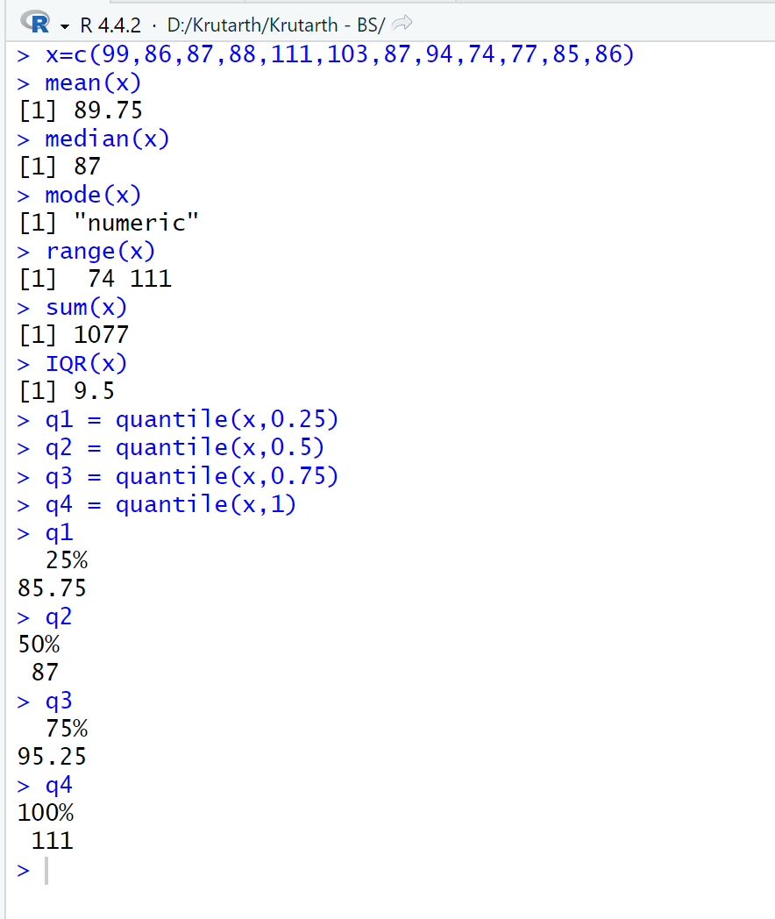

**QUE-2 :** CALCULATE x=3, y=2, z=-5 FOR (x^3)-(2*x*y^2)+(3*z)+(z^2)

ENTRY: x=3

y=2

z=-5

a=(x^3)-(2*x*y^2)+(3*z)+(z^2)

a

ANSWER :

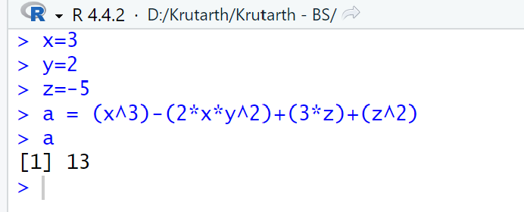

**QUE-3 :** how to get data from que-3.csv file in R.

ENTRY :

data1=read.csv("Z:\\Krutarth - BS\\que-3.csv",header = TRUE)

x=data1$x

x

#CALCULATE mean

mean_x<-mean(x)

print(paste("Mean = ", mean_x))

#CALCULATE median

median_x<-median(x)

print(paste("median = ", median_x))

#CALCULATE mode

mode_x<-mode(x)

print(paste("mode = ", mode_x))

#CALCULATE range

range_x<-max(x)-min(x)

print(paste("range = ", range_x))

#CALCULATE quartiles

res<-quantile(x, probs = c(0,0.25,0.5,0.75,1))

print(res)

#CALCULATE IQR

iqr_x<-IQR(x)

print(paste("IQR = ", iqr_x))

ANSWER :

|  |
| --- |
|  |
| |  | | --- | |  | | **Day-2:**  **QUE-4 :** CALCULATE x=5, y=3, z=-4 FOR a=(x^2)-(2*x*y)+(3*z)+(z^2)  ENTRY: x=5  y=3  z=-4  a=(x^2)-(2*x*y)+(3*z)+(z^2)  a  answer:    **QUE-5:** how to get data from que-5.csv file in R.  ENTRY :  data1=read.csv("Z:\\Krutarth - BS\\que-5.csv",header = TRUE)  data1  x=data1$x  x  #CALCULATE mean  mean_x=mean(x)  print(paste("Mean = ", mean_x))  #CALCULATE median  median_x=median(x)  print(paste("median = ", median_x))  ANSWER : | |

**QUE-6:** Print 4 to 100 sequence.

ENTRY : x=seq(4,100,6)

X

ANSWER:

x=seq(4,100,6)

> x

[1] 4 10 16 22 28 34 40 46 52 58 64 70 76 82 88 94 100

**Day-3:**

**QUE-7:** Create a vector X with data set (1, 2, 3, 4, 5) and vector Y with data set (3, 7, 8, 9, 12). Create line chart and scatter chart in R

ENTRY : x=c(1,2,3,4,5)

y=c(3,7,8,9,12)

x

y

plot(x,y,type = 'l',xlab = "Height",ylab = "weight",main = "line daigram",col="red")

ANSWER: 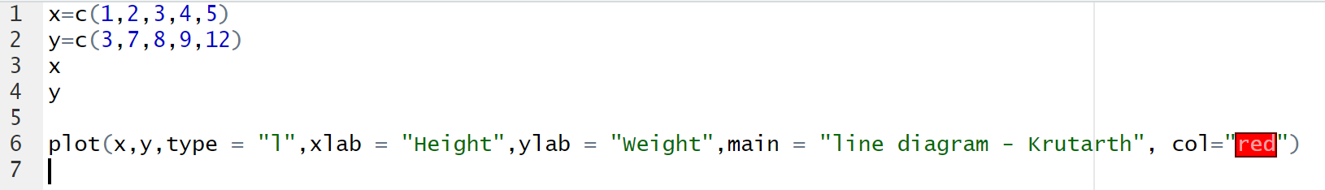

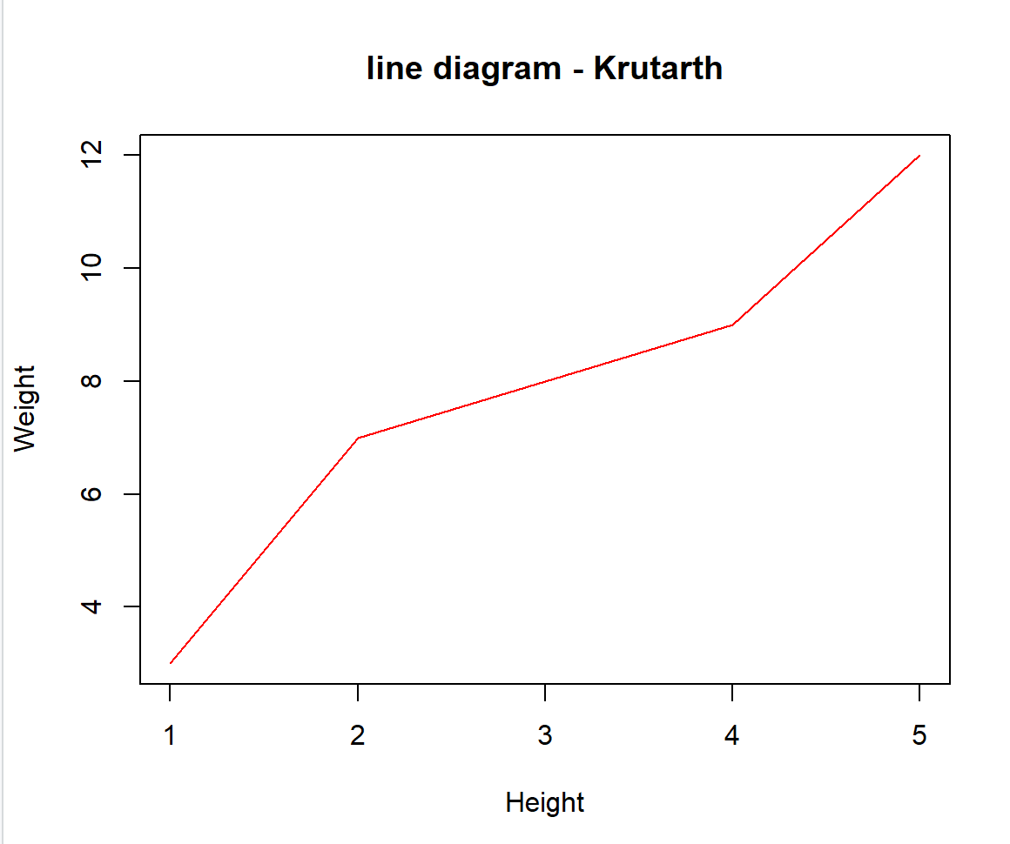

**QUE-8:** Write a program in R to create pie chart for vector (10, 20, 30, 40) with appropriate label and colors.

ENTRY : x=c(10,20,30,40)

pie(x, init.angle = 90)

mylabel<-c("Apple","Banana","Cherry","Dates")

colors<-c("Blue","Yellow","Green","Red")

pie(x, label = mylabel, main="Fruits", col = colors)

ANSWER:

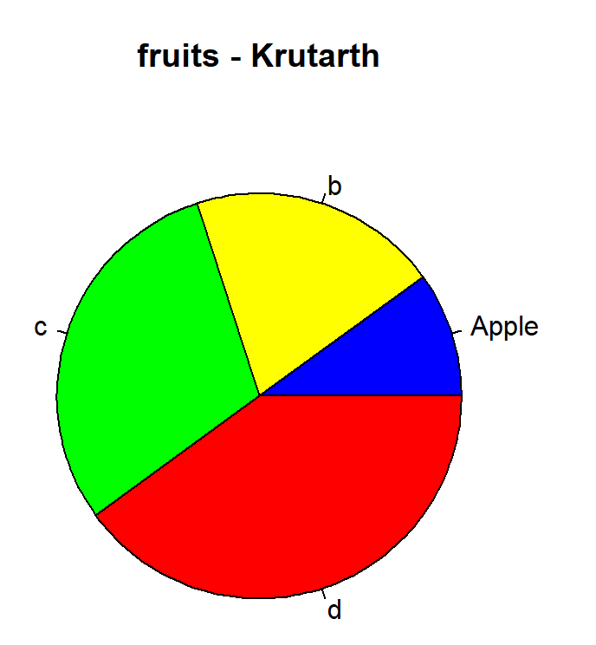

**QUE-9:** Create file (data.csv) using following data 33.5 ,57.1 ,49.7 ,40.2, 44.2, 45.2, 47.8, 38.0 ,53.9 ,41.1 ,41.7, 40.8 ,55.5 ,43.5 ,49.1 Write a program in R to calculate variance, standard deviation and coefficient of variation for given data.

ENTRY : data1=read.csv("Z:\\Krutarth - BS\\que-5.csv",header = TRUE)

data1

x=data1$x

x

var=var(x)

s=sd(x)

xbar=mean(x)

var

s

xbar

cv=s/xbar*100

cv

ANSWER:

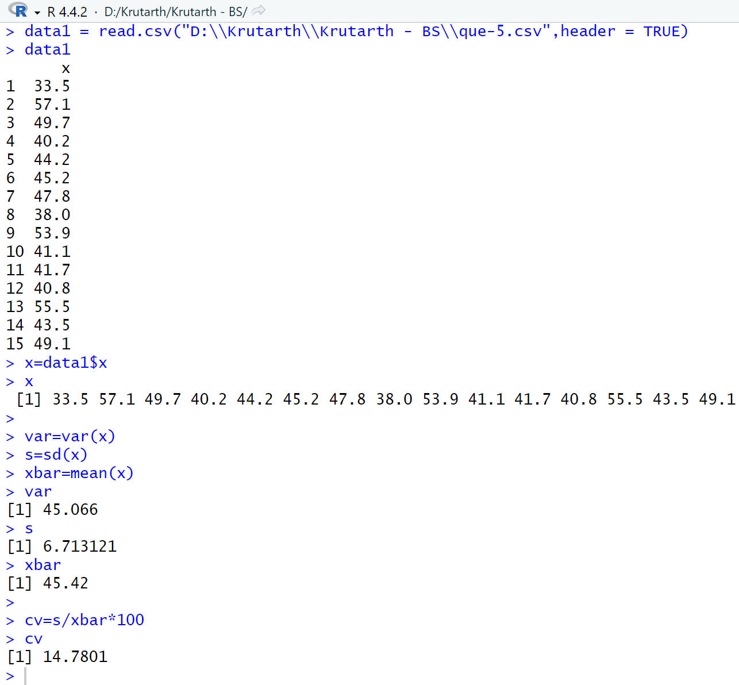

**Day-4:**

**QUE-10:** Create a vector X with data set (“A”,”B”,”C”,”D”) and vector Y with data set (2, 4, 6, 8). Create horizontal and vertical Bar chart in R.

ENTRY : x=c("A","B","C","D")

y=c(2, 4, 6, 8)

barplot(y,names.arg=x,main="Bargraph",xlab="category",ylab="Frequency",col="blue",density=25,border="red")

ANSWER: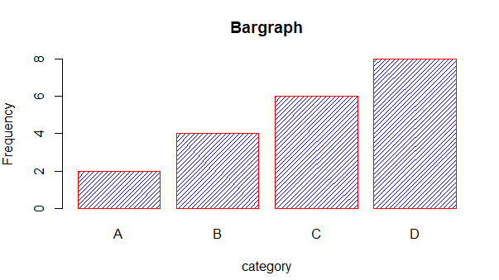

Add: horiz=2 for horizontal

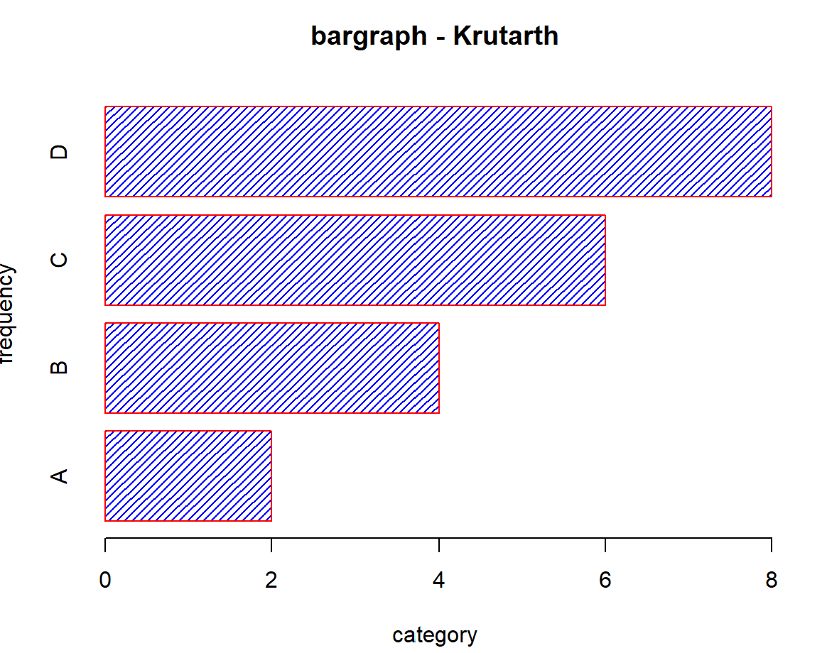

**QUE-11:** Write a program in R to create histogram for vector (19, 23, 11, 5, 16, 21, 32,14, 19, 27, 39).

ENTRY : data1=read.csv("Z:\\Krutarth - BS\\que-11.csv",header = TRUE)

x=data1$x

x

hist(x,xlab="Weight",ylab="Height",main="Histogram",col="blue",density=25,border="red")

ANSWER: 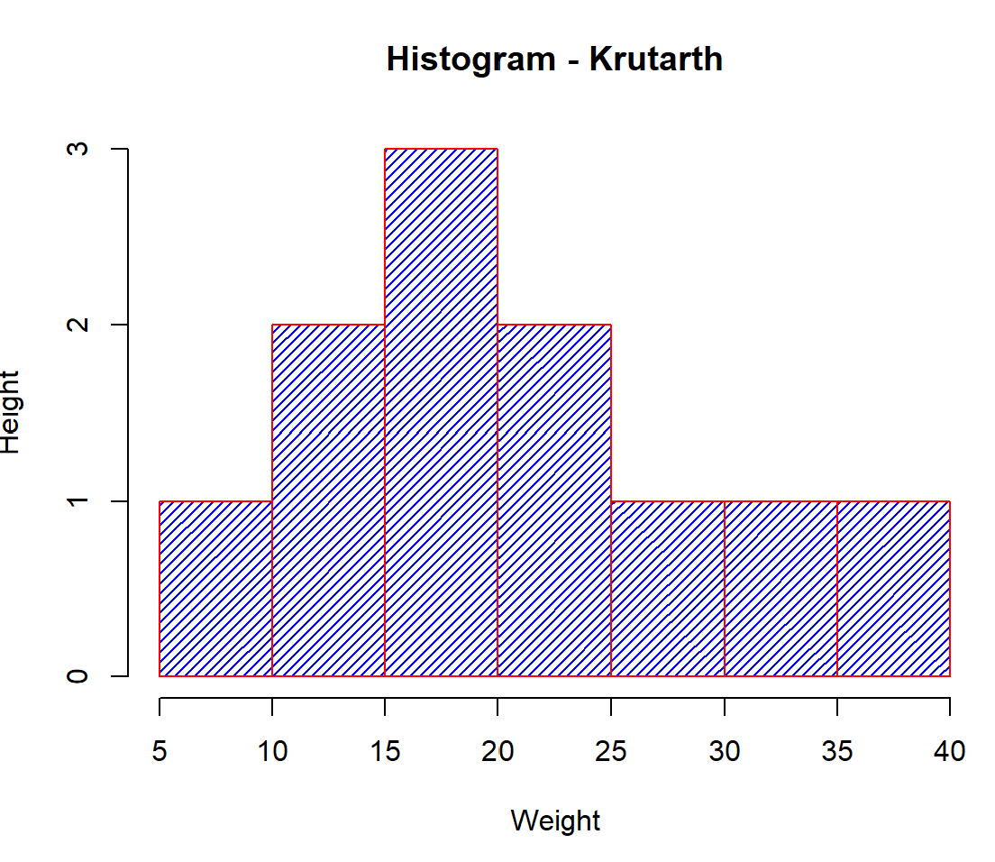

**QUE-12:** Write a program to create box plot for mtcars dataset available in R. (19, 23, 11, 5, 16, 21, 32,14, 19, 27, 39).

ENTRY : x=c(19, 23, 11, 5, 16, 21, 32,14, 19, 27,42)

x

res = quantile(x, probs = c(0,0.25,0.5,0.75,1))

print(res)

f=IQR(x)

f

q1=quantile(x,0.25)

q2=quantile(x,0.75)

q1

li=q1-(1.5*f)

ui=q2+(1.5*f)

li

ui

boxplot(x,col = "red", border = "blue", main="Boxplot",range=2,horizontal = 1)

ANSWER: > x=c(19, 23, 11, 5, 16, 21, 32,14, 19, 27,42)

> x

[1] 19 23 11 5 16 21 32 14 19 27 42

> res = quantile(x, probs = c(0,0.25,0.5,0.75,1))

> print(res)

0% 25% 50% 75% 100%

5 15 19 25 42

> f=IQR(x)

> f

[1] 10

> q1=quantile(x,0.25)

> q2=quantile(x,0.75)

> q1

25%

15

> li=q1-(1.5*f)

> ui=q2+(1.5*f)

> li

25%

0

> ui

75%

40

> boxplot(x,col = "red", border = "blue", main="Boxplot",range=2,horizontal = 1)

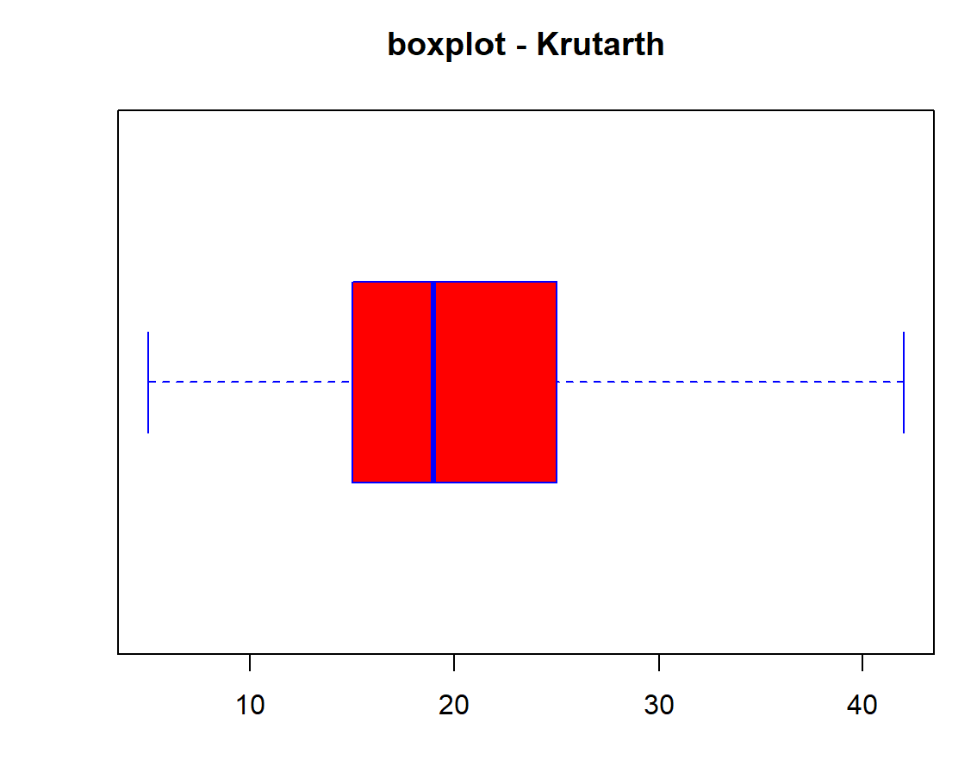

**QUE-13: datasets::mtcars**

**boxplot(mtcars,horizontal = T)**

**x=mtcars$mpg**

**x**

**boxplot(x)**

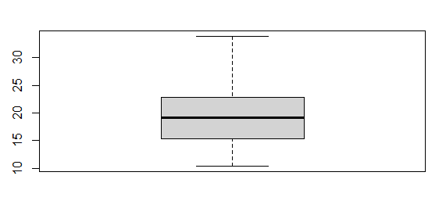

**Day-5:**

**QUE-14:** Create a vector X with data set (5,7,8,7,2,2,9,4,11,12,9,6) and vector Y with data set (99,86,87,88,111,103,87,94,78,77,85,86). Create line chart and scatter chart in R with appropriate labels and color coding.

ENTRY : x=c(5,7,8,7,2,2,9,4,11,12,9,6)

y=c(99,86,87,88,111,103,87,94,78,77,85,86)

plot(x,y,abline(lm(y~x)))

scatter.smooth(x,y)

ANSWER: 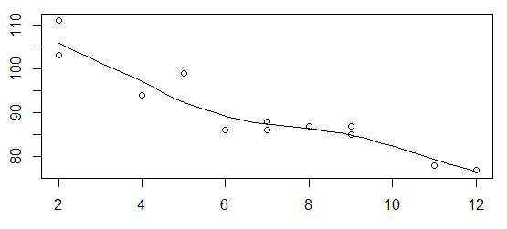

Imp

* if r = +1 then their exist perfect positive co-relation.
* if r = 11 then their exist perfect negative co-relation.
* if r=0 then these is no co-relation.
* if r=0 to r=0.5 then low-order partial positive co-relation.
* if r=0.5 to r=1 then high-order partial positive co-relation.
* if r=0 to r= -0.5 then low-order partial negative co-relation.
* if r= -0.5 to r= -1 then high-order partial negative co-relation.

//What is the main difference between co-relation and relation?

**QUE-15:** For the following Data X 2 3 5 1 8 Y 25 25 20 30 16 Calculate

1. Calculate correlation and interpret

2. Calculate covariance

3. Develop a Scatter diagram for this data.

4. Compute the estimated regression equation.

5. Predict value of Y for X=4 6. Predict value of X for Y=23

ENTRY : x=c(2,3,5,1,8)

y=c(25, 25, 20, 30, 16)

#obtain correlation

r=cor(x,y)

print(paste("The correlation of the given data is : ",r))

#obtain covariance

co=cov(x,y)

print(paste("The covariance of the given data is : ",co))

plot(y,x,col="blue",main="Salary & bonus",abline(lm(x~y),col="red"),cex=1.5,pch=16,xlab="salary",ylab="bonus")

#regression line y on x ycap = b0 + blx

relation <- lm(x~y)

print(relation)

print(summary(relation))

ycap=30.331-(1.877*4)

ycap

#find y for x=4

a<-data.frame(x=4)

result<-predict(relation,a)

print(result)

#regression line x on y xcap = b0+b1y

relation1=lm(x~y)

print(relation1)

xcap=15.4808-(0.5035*23)

xcap

#find x for y=23

b<-data.frame(x=23)

result1<-predict(relation1,b)

print(result1)

ANSWER:

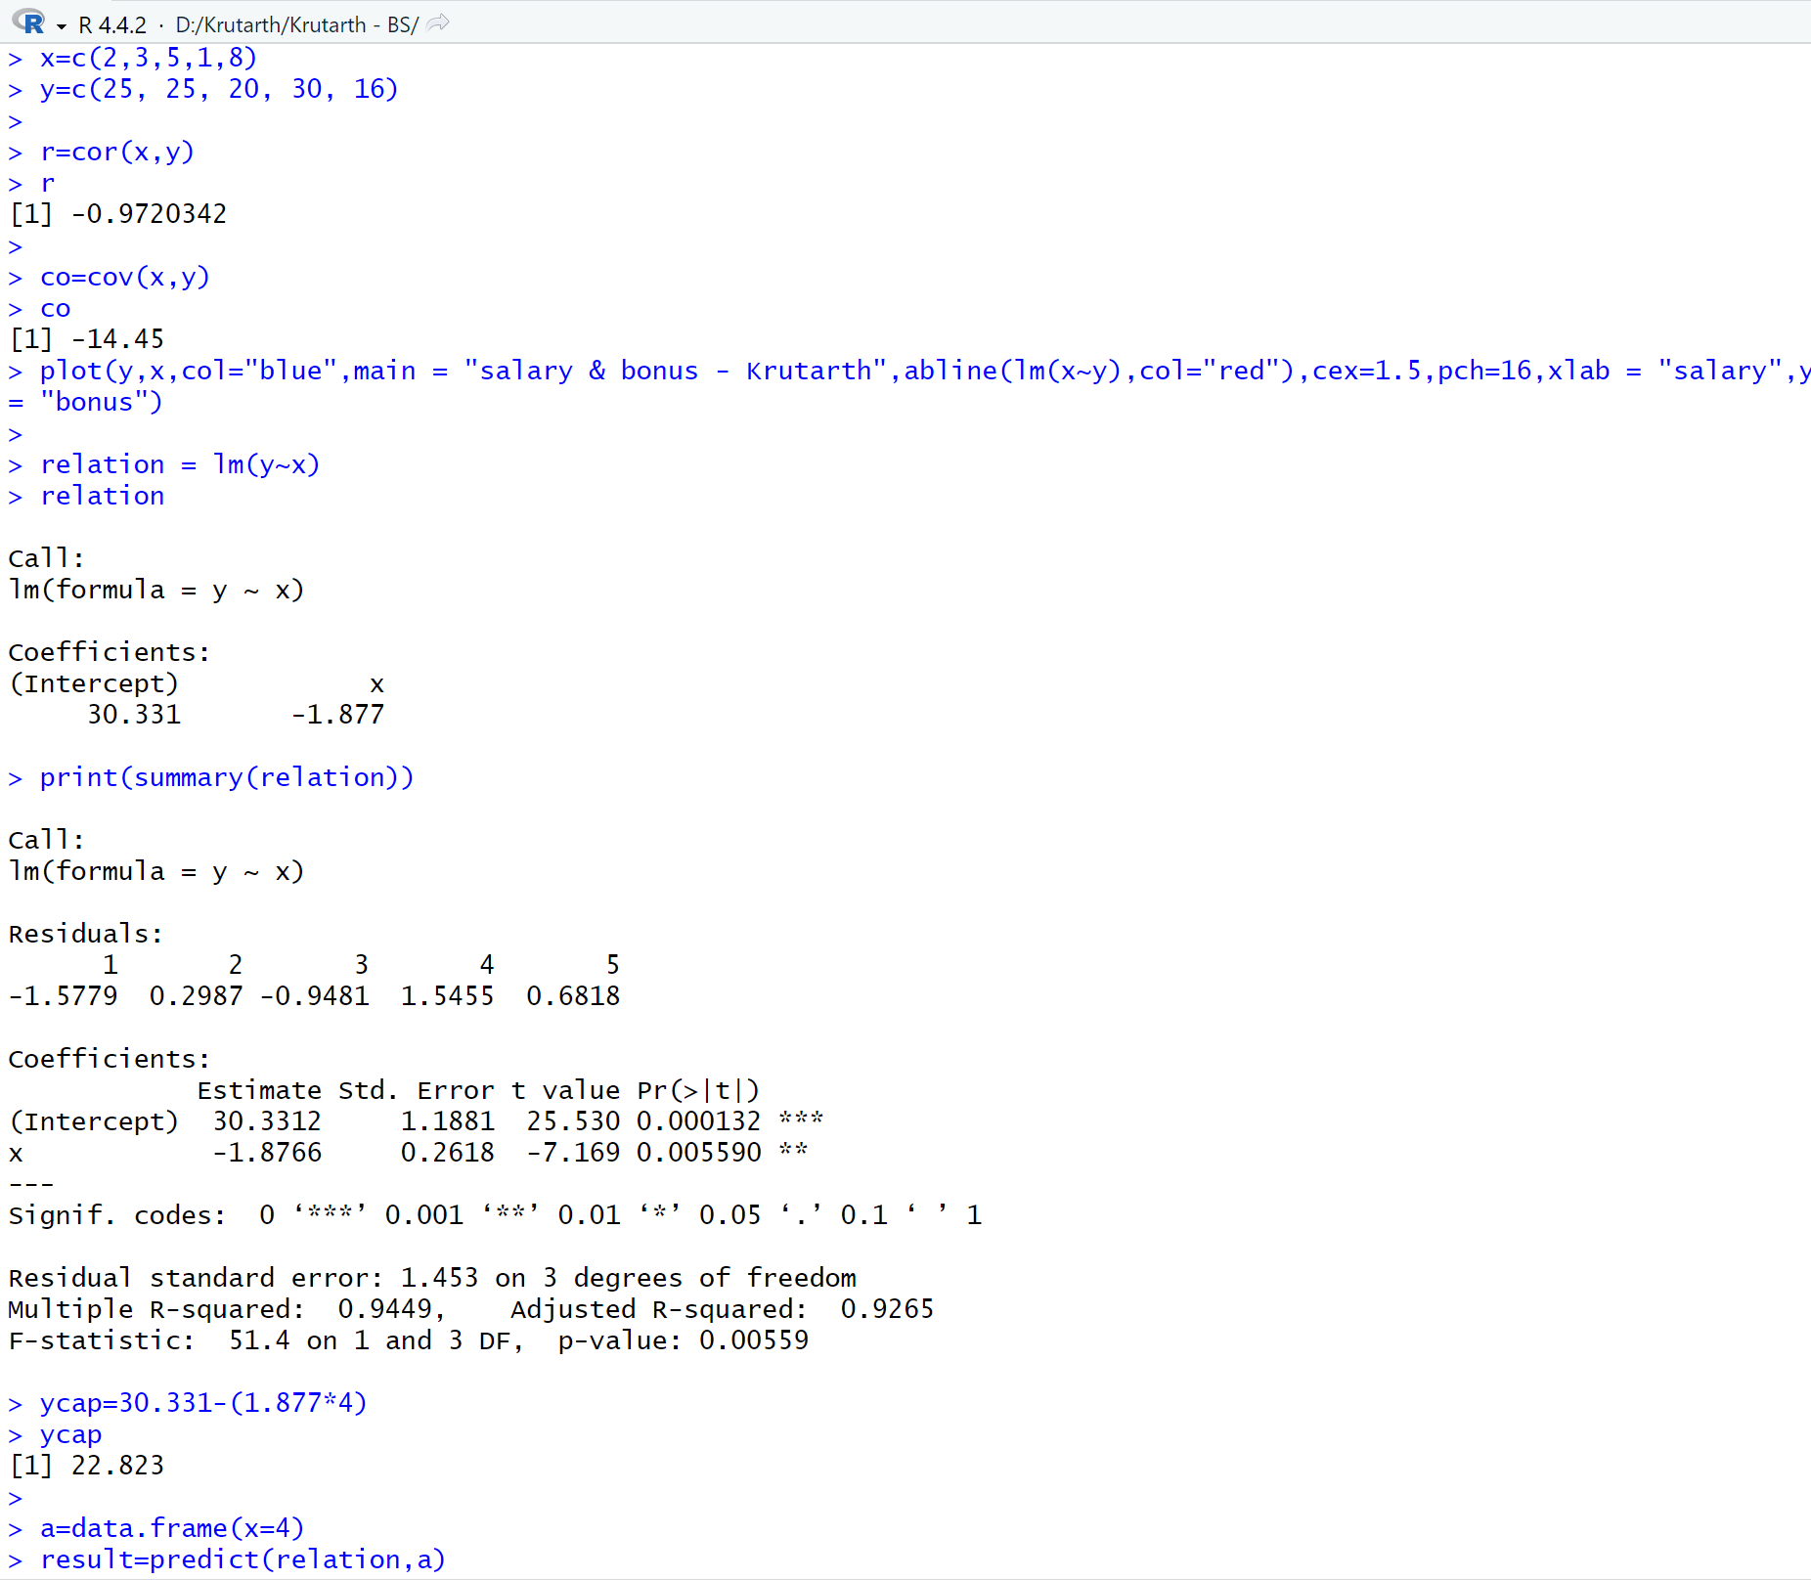

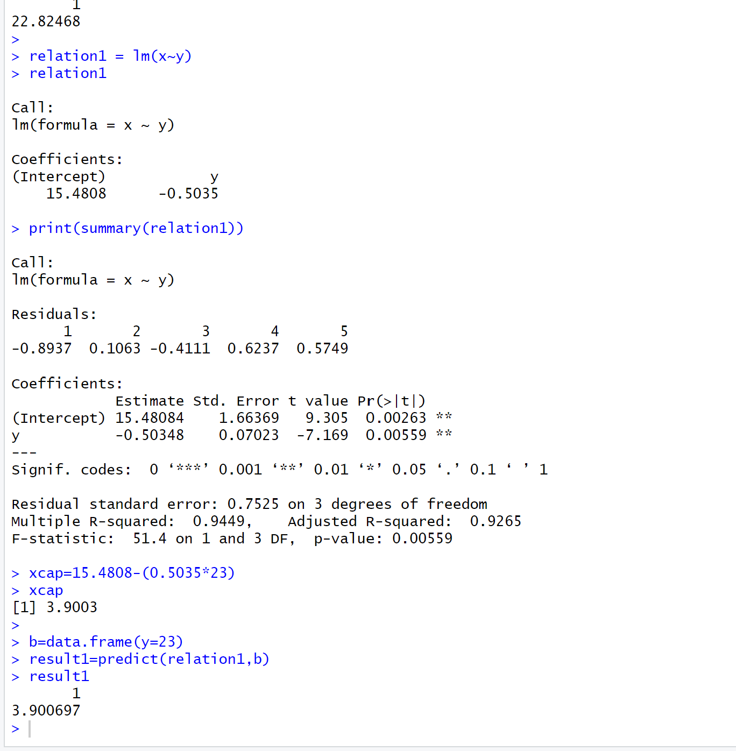

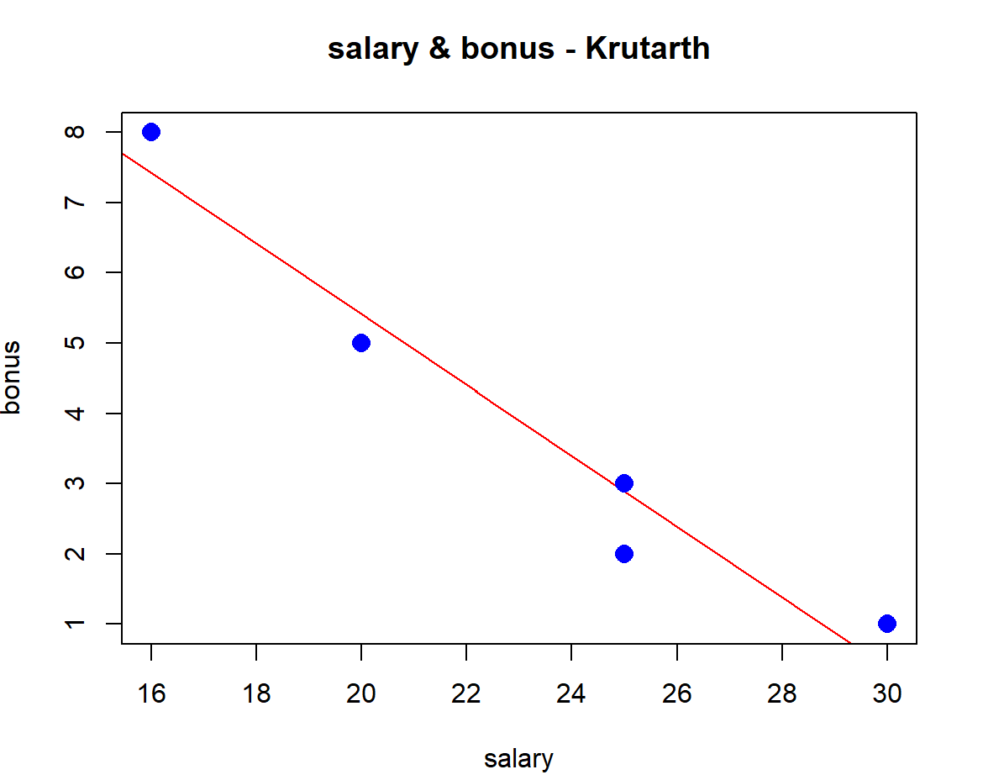

**Day-6:**

**QUE-16:** Write a program in R to create csv file for given data set and calculate the following:

Salary 110 130 140 160 170 90 100 130 150

Bonus 12 15 14 15 20 12 10 12 18

1. Calculate correlation and interpret 2. Calculate covariance

3. Develop a Scatter diagram for this data.

4. Compute the estimated regression equation.

5. Predict value of Bonus for salary=105

6. Predict value of Salary for Bouns=14

ENTRY : data1=read.csv("Z:\\Krutarth - BS\\que-16.csv",header = TRUE)

data1

x=data1$x

y=data1$y

x

y

# correlation

r=cor(x,y)

print(paste("The correltaion of the given data is: ",r))

# covarition

co=cov(x,y)

print(paste("The covarition of the given data is: ",co))

plot(y,x,col ="red",main="Scatter Diagram",abline(lm(x~y),col="blue"))

#regression line y on x

yonx=lm(y~x)

print(yonx)

xcap=1.13585 +(0.09981*105)

a=data.frame(x=105)

result=predict(yonx,a)

print(result)

#regression line x on y

xony=lm(x~y)

print(xony)

ycap=28.610 +(7.207*14)

b=data.frame(y=14)

result1=predict(xony,b)

print(result1)

ANSWER: 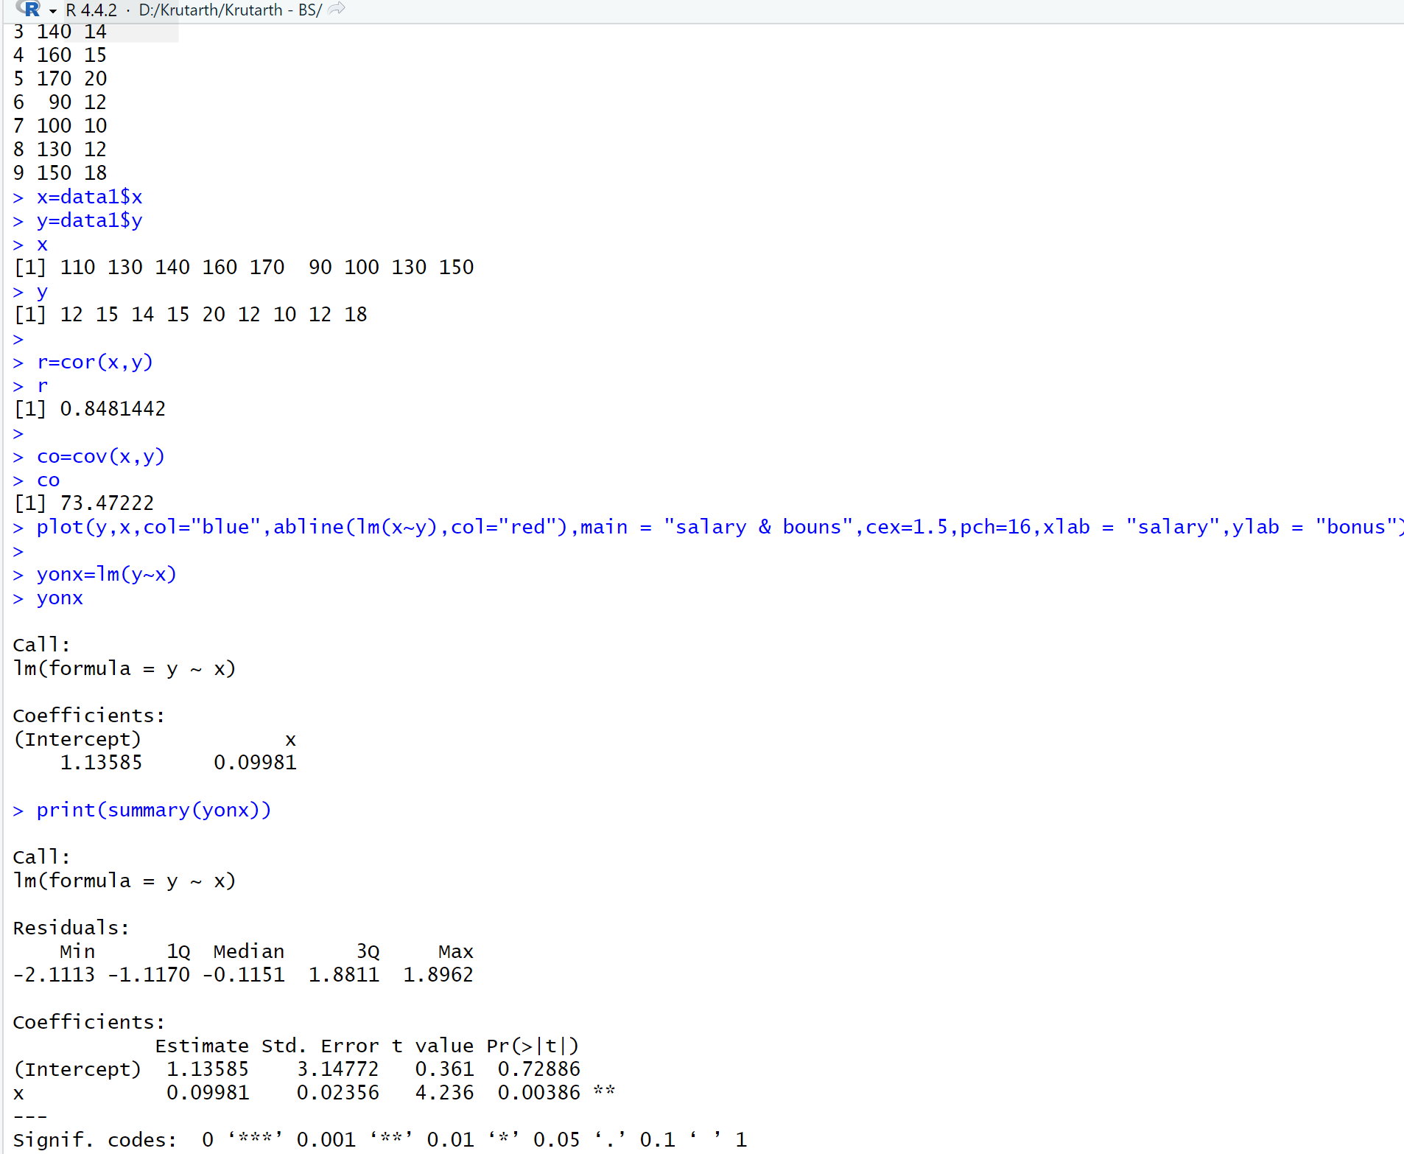

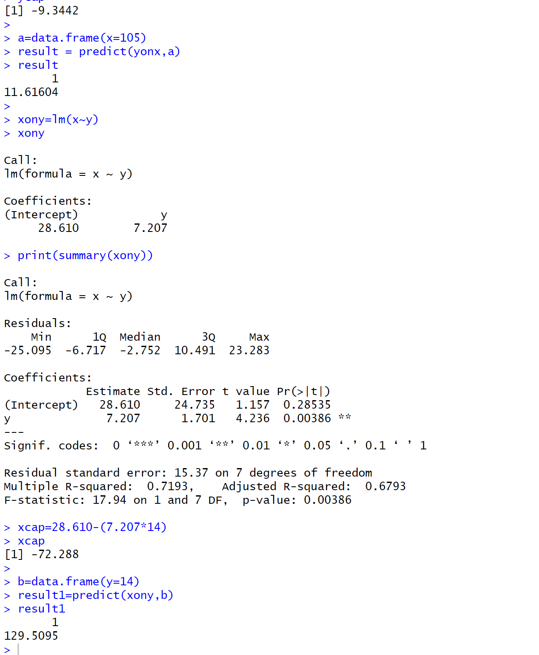

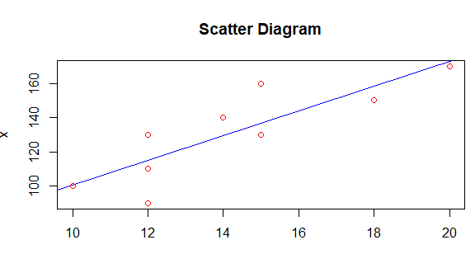

**Day-7:**

**QUE-17:** Generating random numbers. Set your seed to 1 and generate 10 random numbers using runif and save it in an object called random_numbers

ENTRY : set.seed(1)

random_numbers=runif(10,1,5)

random_numbers

# interger random number

x=seq(1,50,2)

x

ANSWER: 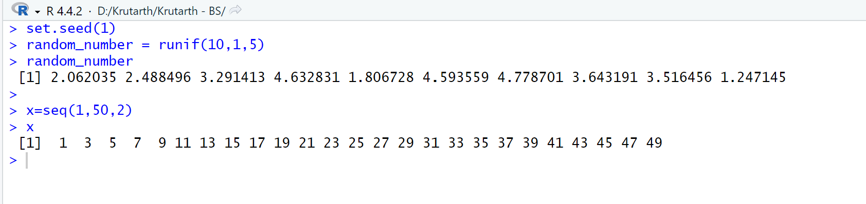

Distribution

|

| |

Discrete Continuous

| |

----------------------- normal

| |

Binomial Poisson

P(x)=n(x p^x q^n-x)

🡪where, n = sample size(approx: 20 to 30)

Where, q=1-p

**Day-8:**

**QUE-18: union and interaction of x1=c(1,2,3,4,5,6,7) x2=c(2,5,7,9,10)**

ENTRY : x1=c(1,2,3,4,5,6,7)

x2=c(2,5,7,9,10)

x3=union(x1,x2)

print(paste("The unioun of two sets is ",x3))

x4=intersect(x1,x2)

print(paste("The intersection of two sets is",x4))

print(x3)

print(x4)

ANSWER: > x1=c(1,2,3,4,5,6,7)

> x2=c(2,5,7,9,10)

> x3=union(x1,x2)

> print(paste("The unioun of two sets is ",x3))

[1] "The unioun of two sets is 1" "The unioun of two sets is 2"

[3] "The unioun of two sets is 3" "The unioun of two sets is 4"

[5] "The unioun of two sets is 5" "The unioun of two sets is 6"

[7] "The unioun of two sets is 7" "The unioun of two sets is 9"

[9] "The unioun of two sets is 10"

> x4=intersect(x1,x2)

> print(paste("The intersection of two sets is",x4))

[1] "The intersection of two sets is 2" "The intersection of two sets is 5"

[3] "The intersection of two sets is 7"

> print(x3)

[1] 1 2 3 4 5 6 7 9 10

> print(x4)

[1] 2 5 7

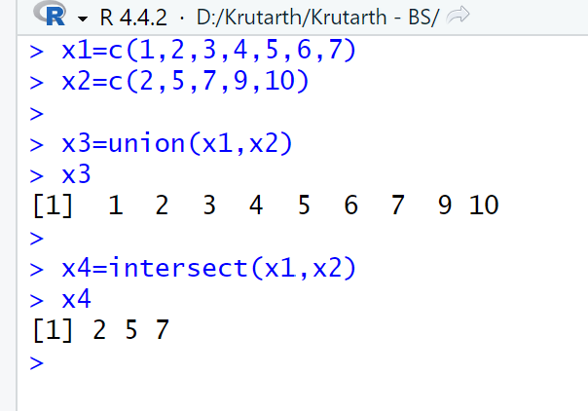

**QUE-19:** Assuming that half of the Indian population is vegetarian. Estimate how many investigators out of 100 will report that 3 or less are vegetarian in the sample of 10 individuals

ENTRY : #method 2

p1=pbinom(3,10,0.5)

p1

print(paste("The prob. of 3 or less are veg. is ",p1))

# method 1

d1=dbinom(0,10,0.5)

d2=dbinom(1,10,0.5)

d3=dbinom(2,10,0.5)

d4=dbinom(3,10,0.5)

d=d1+d2+d3+d4

d

ANSWER: > p1=pbinom(3,10,0.5)

> p1

[1] 0.171875

> print(paste("The prob. of 3 or less are veg. is ",p1))

[1] "The prob. of 3 or less are veg. is 0.171875"

>

> d1=dbinom(0,10,0.5)

> d2=dbinom(1,10,0.5)

> d3=dbinom(2,10,0.5)

> d4=dbinom(3,10,0.5)

> d=d1+d2+d3+d4

> d

[1] 0.171875

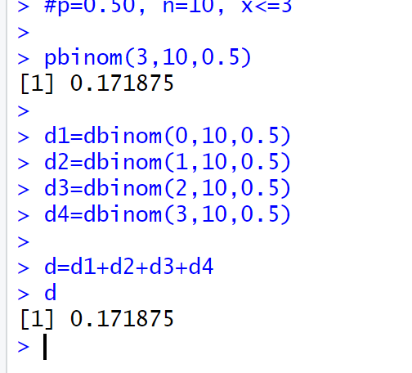

**QUE-20:** In a city of some western country 70 % of the married persons take divorce. What is The Probability that at least three among four persons will take divorce?

ENTRY : # P=0.7,N=4,X>=3

p2=pbinom(2,4,0.7,lower.tail = FALSE)

p2

p3=dbinom(3,4,0.7) + dbinom(4,4,0.7)

p3

ANSWER: > # P=0.7,N=4,X>=3

> p2=pbinom(2,4,0.7,lower.tail = FALSE)

> p2

[1] 0.6517

>

> p3=dbinom(3,4,0.7) + dbinom(4,4,0.7)

> p3

[1] 0.6517

**QUE-21** Suppose there are twelve multiple choice questions in an English class quiz. Each question has five possible answers, and only one of them is correct. Find the probability of having 1) exactly four and 2) four or less correct answers if a student attempts to answer every question at random.

ENTRY :

d0=dbinom(0,12,0.2)

d1=dbinom(1,12,0.2)

d2=dbinom(2,12,0.2)

d3=dbinom(3,12,0.2)

d4=dbinom(4,12,0.2)

d=d0+d1+d2+d3+d4

d

p=pbinom(4,12,0.2)

p

ANSWER: d0=dbinom(0,12,0.2)

> d1=dbinom(1,12,0.2)

> d2=dbinom(2,12,0.2)

> d3=dbinom(3,12,0.2)

> d4=dbinom(4,12,0.2)

> d=d0+d1+d2+d3+d4

> d

[1] 0.9274445

p=pbinom(4,12,0.2)

p

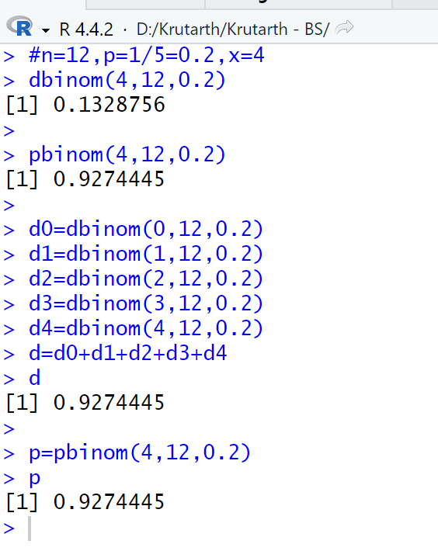

**Day-9:**

**QUE-22 :** AHarris Interactive survey for InterContinental Hotels & Resorts asked respondents, “When traveling internationally, do you generally venture out on your own to experience culture, or stick with your tour group and itineraries?” The survey found that 23% of the respondents stick with their tour group (USA Today, January 21, 2004). a. In a sample of six international travelers, what is the probability that two will stick with their tour group?

b. In a sample of six international travelers, what is the probability that at least two will stick with their tour group?

c. In a sample of 10 international travelers, what is the probability that none will stick with the tour group?

ENTRY : # p=0.23, n=6, x=2

dbinom(2,6,0.23)

# p=0.23, n=6, x>=2

1-(dbinom(0,6,0.23) + dbinom(1,6,0.23))

pbinom(1,6,0.23,lower.tail = FALSE)

# p=0.23, n=10, x=0

dbinom(0,10,0.23)

ANSWER: > # p=0.23, n=6, x=2

> dbinom(2,6,0.23)

[1] 0.2789394

>

> # p=0.23, n=6, x>=2

> 1-(dbinom(0,6,0.23) + dbinom(1,6,0.23))

[1] 0.4180414

> pbinom(1,6,0.23,lower.tail = FALSE)

[1] 0.4180414

>

> # p=0.23, n=10, x=0

> dbinom(0,10,0.23)

[1] 0.0732668

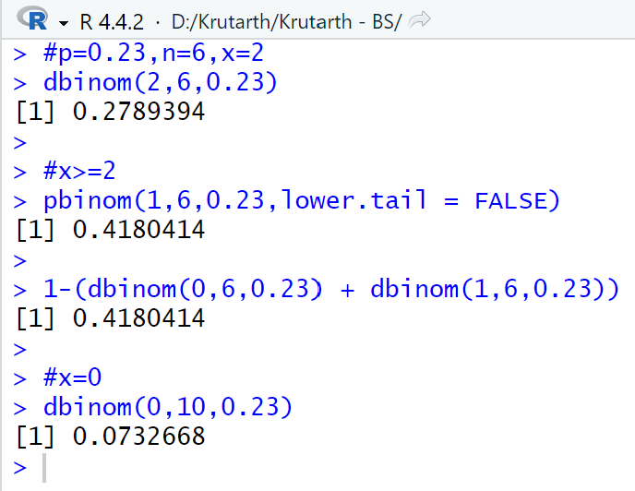

**QUE-23 :** In San Francisco, 30% of workers take public transportation daily (USA Today, December 21, 2005).

a. In a sample of 10 workers, what is the probability that exactly three workers take public transportation daily?

b. In a sample of 10 workers, what is the probability that at least three workers take public transportation daily?

sENTRY : # p=0.30, n=10, x=3

dbinom(3,10,0.3)

# p=0.30, n=10, x=3

pbinom(2,10,0.3,lower.tail = FALSE)

ANSWER : > # p=0.30, n=10, x=3

> dbinom(3,10,0.3)

[1] 0.2668279

>

> # p=0.30, n=10, x=3

> pbinom(2,10,0.3,lower.tail = FALSE)

[1] 0.6172172

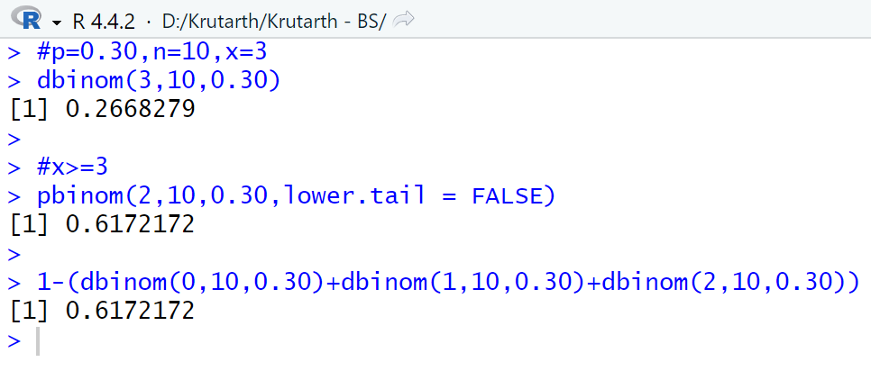

**QUE-24 :** Nine percent of undergraduate students carry credit card balances greater than $7000 (Reader’s Digest, July 2002). Suppose 10 undergraduate students are selected randomly to be interviewed about credit card usage. a. Is the selection of 10 students a binomial experiment? Explain. b. What is the probability that two of the students will have a credit card balance greater than $7000? c. What is the probability that none will have a credit card balance greater than $7000? d. What is the probability that at least three will have a credit card balance greater than $7000?s

ENTRY : # p=0.09, n=10, x=2

dbinom(3,10,0.09)

# p=0.09, n=10, x=0

dbinom(0,10,0.09)

# p=0.09, n=10, x>=3

pbinom(3,10,0.09,lower.tail = FALSE)

ANSWER : > # p=0.09, n=10, x=2

> dbinom(3,10,0.09)

[1] 0.04520625

>

> # p=0.09, n=10, x=0

> dbinom(0,10,0.09)

[1] 0.3894161

>

> # p=0.09, n=10, x>=3

> pbinom(3,10,0.09,lower.tail = FALSE)

[1] 0.008833761

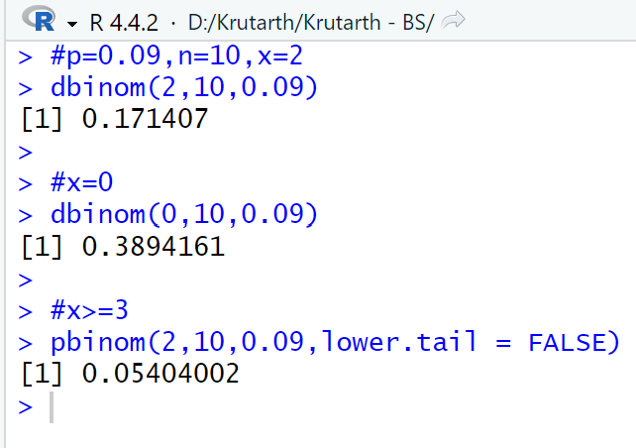

**QUE-25 :** Military radar and missile detection systems are designed to warn a country of an enemy attack. A reliability question is whether a detection system will be able to identify an attack and issue a warning. Assume that a particular detection system has a .90 probability of detecting a missile attack. Use the binomial probability distribution to answer the following questions. a. What is the probability that a single detection system will detect an attack? b. If two detection systems are installed in the same area and operate independently, what is the probability that at least one of the systems will detect the attack? c. If three systems are installed, what is the probability that at least one of the systems will detect the attack? d. Would you recommend that multiple detection systems be used? ExplaiN

ENTRY : # p=0.90, n=0.90, x=1

dbinom(1,1,0.9)

# p=0.90, n=2, x>=1

pbinom(0,2,0.9,lower.tail = FALSE)

# p=0.9, n=3, x>=1

pbinom(0,3,0.90,lower.tail = FALSE)

ANSWER : > # p=0.90, n=0.90, x=1

> dbinom(1,1,0.9)

[1] 0.9

>

> # p=0.90, n=2, x>=1

> pbinom(0,2,0.9,lower.tail = FALSE)

[1] 0.99

>

> # p=0.9, n=3, x>=1

> pbinom(0,3,0.90,lower.tail = FALSE)

[1] 0.999

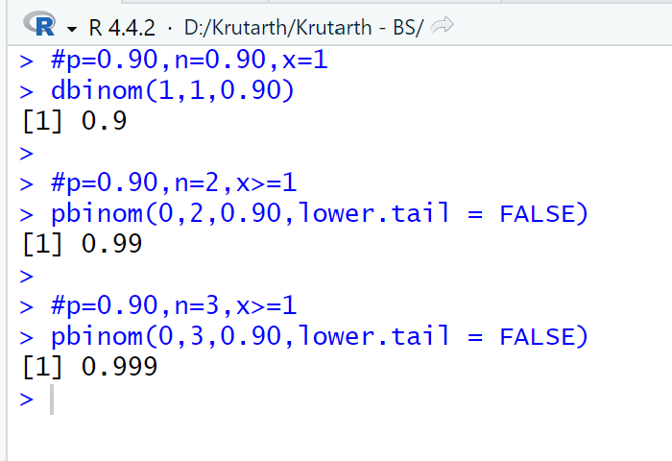

**Day-10:**

**QUE-26 :** Phone calls arrive at the rate of 48 per hour at the reservation desk for Regional airways.

(1) Compute the probability of receiving three calls in a five minute interval of time.

(2) Compute the probability of receiving exactly ten calls in fifteen minutes.

(3) If no calls are being processed, what is the probability that the agent can take three minutes for personal time without being interrupted by a call?

ENTRY : # m=4, x=3

p1=dpois(3,4)

print(paste("Compute the probability of receiving three calls in a five minute interval of time : ",p1))

# m=12, x=10

p2=dpois(10,12)

print(paste("Compute the probability of receiving exactly ten calls in fifteen minutes : ",p2))

# m=2.4, x=0

p3=dpois(0,2.4)

print(paste("If no calls are being processed, what is the probability that the agent can take three minutes for personal time without being interrupted by a call? : ",p3))

ANSWER : "Compute the probability of receiving three calls in a five minute interval of time : 0.195366814813165"

"Compute the probability of receiving exactly ten calls in fifteen minutes : 0.104837255883659"

"If no calls are being processed, what is the probability that the agent can take three minutes for personal time without being interrupted by a call? : 0.0907179532894125"

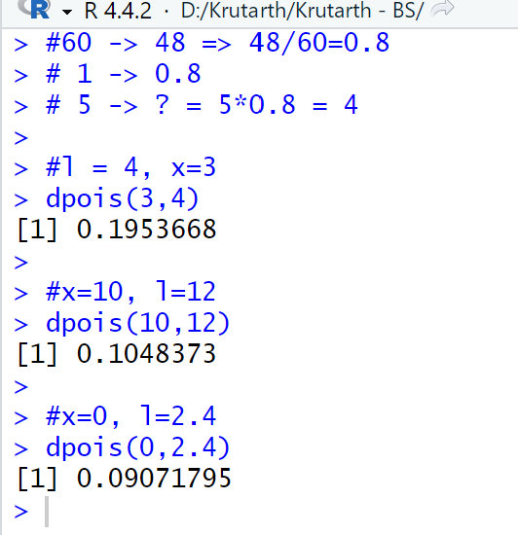

**QUE-27 :** Consider a Poisson distribution with a mean of two occurrences per time period.

a. Write the appropriate Poisson probability function.

b. What is the expected number of occurrences in three time periods?

c. Write the appropriate Poisson probability function to determine the probability of x occurrences in three time periods.

d. Compute the probability of two occurrences in one time period.

e. Compute the probability of six occurrences in three time periods.

f. Compute the probability of five occurrences in two time periods.

ENTRY : # m=2, x=2

p1=dpois(2,2)

p1

# m=5, x=6

p2=dpois(6,5)

p2

# m=5, x=4

p3=dpois(4,5)

p3

ANSWER :

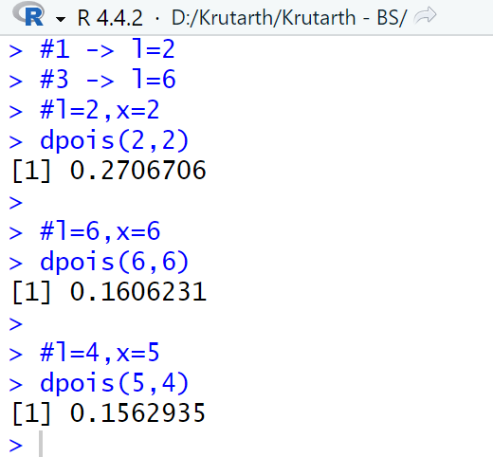

**QUE-28 :** During the period of time that a local university takes phone-in registrations, calls come in at the rate of one every two minutes.

a. What is the expected number of calls in one hour?

b. What is the probability of three calls in five minutes?

c. What is the probability of no calls in a five-minute period?

ENTRY : # m=2.5, x=3

p1=dpois(3,2.5)

p1

# m=2.5, x=0

p3=dpois(0,2.5)

p3

ANSWER :

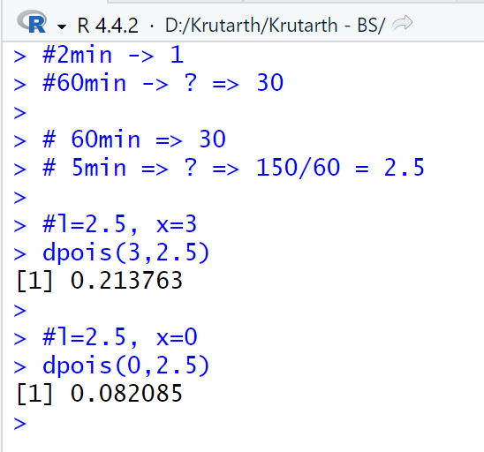

**QUE-29 :** More than 50 million guests stay at bed and breakfasts (B&Bs) each year. The website for the Bed and Breakfast Inns of North America, which averages seven visitors per minute, enables many B&Bs to attract guests (Time, September 2001).

a. Compute the probability of no website visitors in a one-minute period.

b. Compute the probability of two or more website visitors in a one-minute period.

c. Compute the probability of one or more website visitors in a 30-second period.

d. Compute the probability of five or more website visitors in a one-minute period.

ENTRY : # m=7, x=0

p1=dpois(0,7)

p1

p2=ppois(1,7,lower.tail = FALSE)

p2

p3=ppois(0,3.5,lower.tail = FALSE)

p3

p4=ppois(4,7,lower.tail = FALSE)

p4

ANSWER : # m=7, x=0

> p1=dpois(0,7)

> p1

[1] 0.000911882

>

>

> p2=ppois(1,7,lower.tail = FALSE)

> p2

[1] 0.9927049

>

> p3=ppois(0,3.5,lower.tail = FALSE)

> p3

[1] 0.9698026

>

> p4=ppois(4,7,lower.tail = FALSE)

> p4

[1] 0.8270084

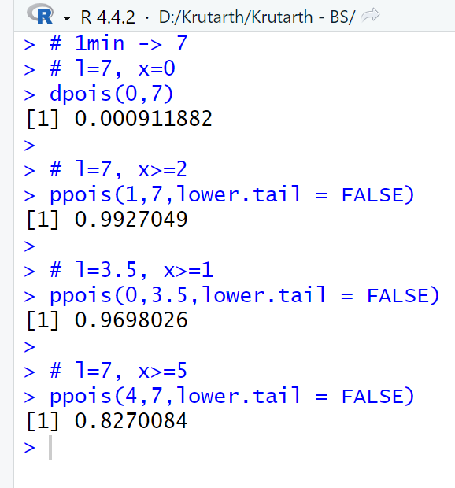

**Day-11:**

**QUE-30 :** Airline passengers arrive randomly and independently at the passenger-screening facility at a major international airport. The mean arrival rate is 10 passengers per minute.

a. Compute the probability of no arrivals in a one-minute period.

b. Compute the probability that three or fewer passengers arrive in a one-minute period.

c. Compute the probability of no arrivals in a 15-second period.

d. Compute the probability of at least one arrival in a 15-second period.

ENTRY : # m=10, x=0

p1=dpois(0,10)

p1

p2=ppois(3,10,lower.tail = FALSE)

p2

p3=dpois(0,2.5)

p3

p4=1-p3

p4

ANSWER : > # m=10, x=0

> p1=dpois(0,10)

> p1

[1] 4.539993e-05

>

>

> p2=ppois(3,10,lower.tail = FALSE)

> p2

[1] 0.9896639

>

> p3=dpois(0,2.5)

> p3

[1] 0.082085

>

> p4=1-p3

> p4

[1] 0.917915

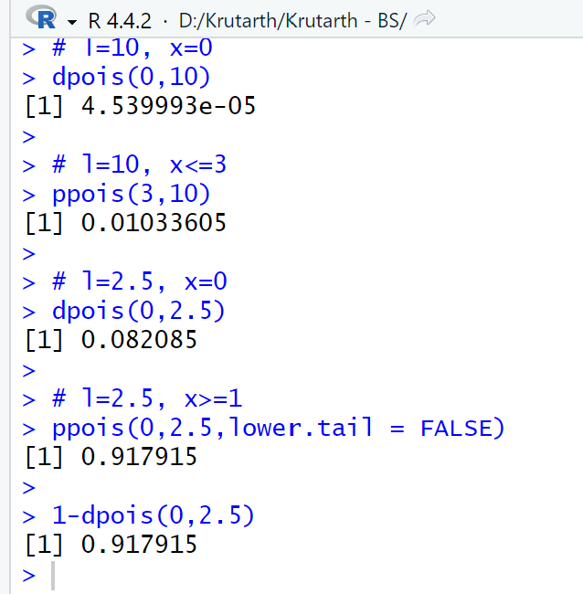

**QUE-31 :** An average of 15 aircraft accidents occur each year (The World Almanac and Book of Facts, 2004).

a. Compute the mean number of aircraft accidents per month.

b. Compute the probability of no accidents during a month.

c. Compute the probability of exactly one accident during a month.

d. Compute the probability of more than one accident during a month.

ENTRY : # m=15/12=1.25, x=0

p1=dpois(0,1.25)

p1

p2=ppois(0,1.25,lower.tail = FALSE)

p2

p3=ppois(1,1.25,lower.tail = FALSE)

p3

p4= 1 - ppois(1,1.25)

p4

ANSWER : > # m=15/12=1.25, x=0

> p1=dpois(0,1.25)

> p1

[1] 0.2865048

>

>

> p2=ppois(0,1.25,lower.tail = FALSE)

> p2

[1] 0.7134952

>

> p3=ppois(1,1.25,lower.tail = FALSE)

> p3

[1] 0.3553642

>

> p4= 1 - ppois(1,1.25)

> p4

[1] 0.3553642

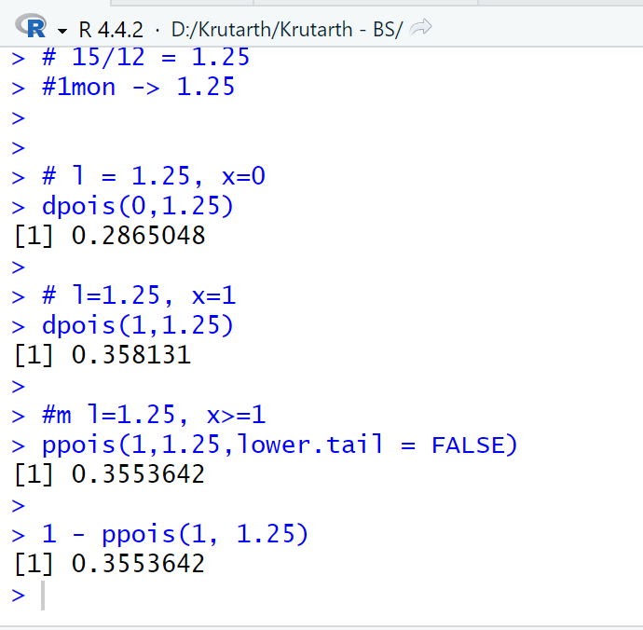

**QUE-32 :** The National Safety Council (NSC) estimates that off-the-job accidents cost U.S. businesses almost $200 billion annually in lost productivity (National Safety Council, March 2006). Based on NSC estimates, companies with 50 employees are expected to average three employee off-the-job accidents per year. Answer the following questions for companies with 50 employees.

a. What is the probability of no off-the-job accidents during a one-year period?

b. What is the probability of at least two off-the-job accidents during a one-year period?

c. What is the expected number of off-the-job accidents during six months?

d. What is the probability of no off-the-job accidents during the next six months?

ENTRY : # m=3, x=0

p1 = dpois(0, 3)

p1

p2 = ppois(1, 3, lower.tail = TRUE)

p2

#12->M=3 TO 6->? MEANS M=1.5

p3 = dpois(0, 1.5)

p3

ANSWER :

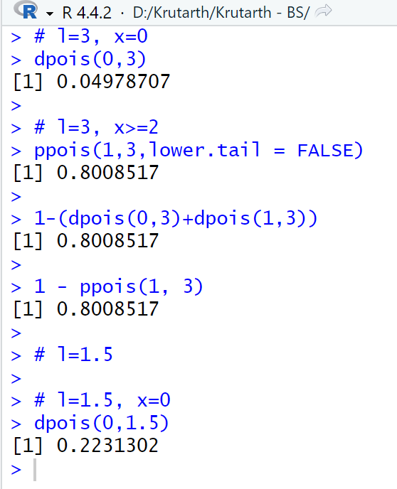

**Extra : QUE-33 :**

**Entry :**

# Q1 :: 1min -> 12

# l=12, x>=17

ppois(16,12,lower.tail = FALSE)

# Q2 :: p=0.40,n=10,x=2

dbinom(2,10,0.40)

# Q3 :: p=0.03, n=2,x=1

dbinom(1,2,0.03)

# p=0.03, n=2,x=0,x=1,x=2

dbinom(0,2,0.03)

dbinom(1,2,0.03)

dbinom(2,2,0.03)

# Q4 :: p=0.5, n=20,x=12

dbinom(12,20,0.5)

# p=0.5, n=20,x<=5

pbinom(5,20,0.5)

#20 * 0.50=10

# Q5 :: p=0.28, n=15,x=4

dbinom(4,15,0.28)

# Q5 :: p=0.28, n=15,x>=3

pbinom(2,15,0.28,lower.tail = FALSE)

# Q6 :: p=0.20, n=20,x<=2

pbinom(2,20,0.20)

# Q6 :: p=0.20, n=20,x=4

dbinom(4,20,0.20)

# Q6 :: p=0.20, n=20,x>=3

pbinom(3,20,0.20,lower.tail = FALSE)

**Answer :**

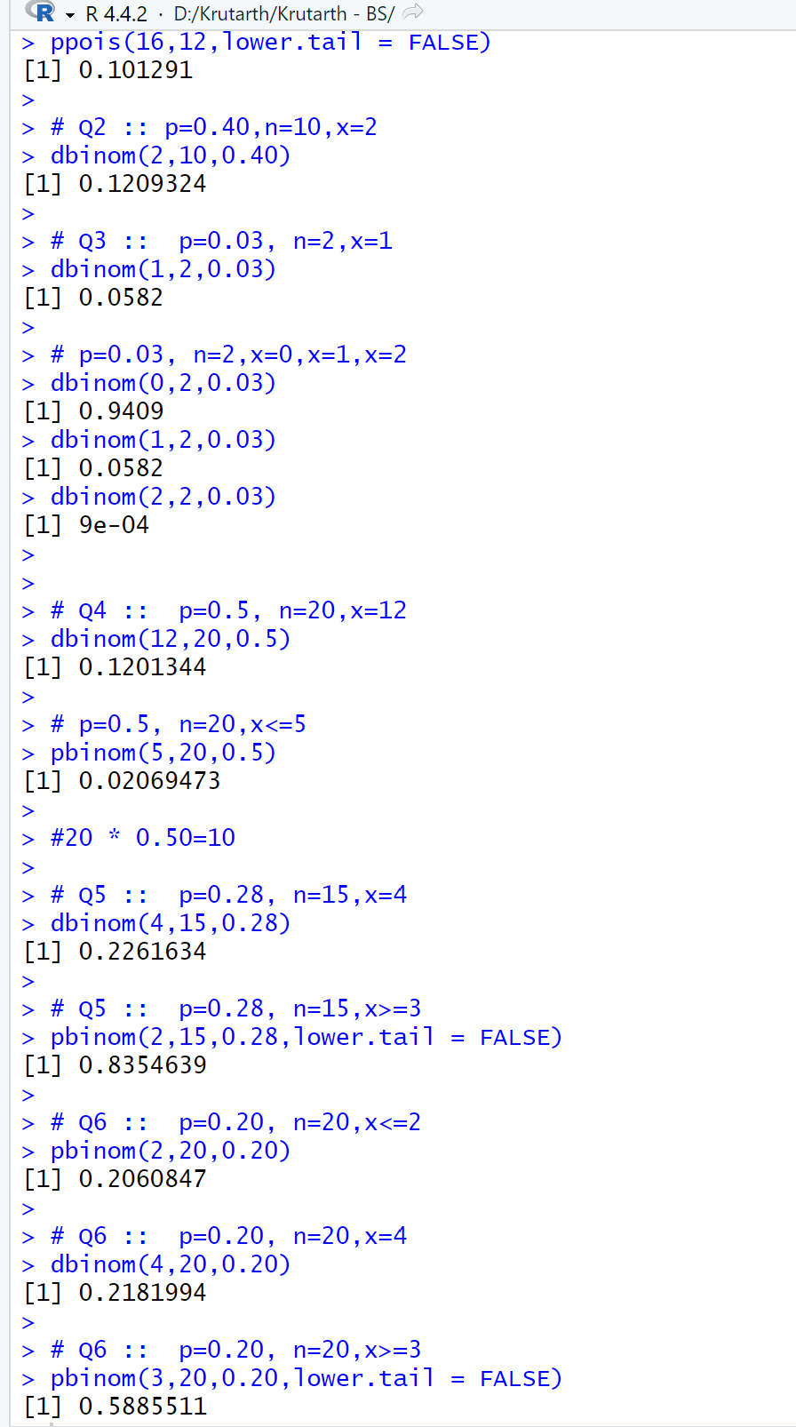

**Que-34 : Given that z is a standard normal random variable, compute the following probabilities.**

**# a. P(0 =< z =< 0.83)**

**# b. P(-1.57 <= z <= 0)**

**# c. P(z >= 0.44)**

**# d. P(z >= -0.23)**

**# e. P(z < 1.20)**

**# f. P(z <= -0.71)**

**# g. P(-1.98 <= z <= 0.49)**

**# h. P(0.52 <= z <= 1.22)**

**# i. P(-1.75 <= z <= -1.04)**

**# mean=72, sigma/sd= 15.2, x >=84**

**Entry :**

# mean=72, sigma/sd= 15.2, x >=84

p1 = pnorm(84,72,15.2,lower.tail = FALSE)

p1

p2 = pnorm(-1,0,1)

p2

pnorm(0.83,0,1) - pnorm(0,0,1)

pnorm(0,0,1) - pnorm(-1.57,0,1)

pnorm(0.44,0,1, lower.tail = FALSE)

pnorm(-0.23,0,1, lower.tail = FALSE)

pnorm(1.20,0,1)

pnorm(-0.71,0,1)

pnorm(0,0,1) - pnorm(-1.98, 0.49, 1)

pnorm(0,0,1) - pnorm(0.52, -1.22, 1)

pnorm(0,0,1) - pnorm(-1.75, -1.04, 1)

**Answer :**

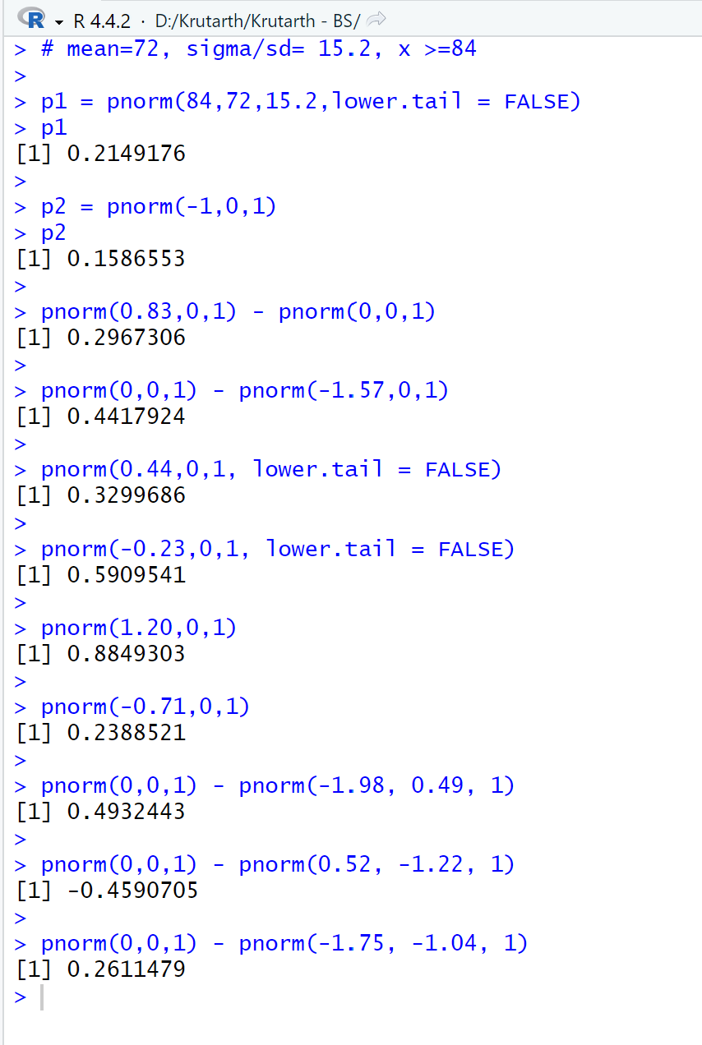

**Que-35 : For borrowers with good credit scores, the mean debt for revolving and installment accounts is $15,015 (BusinessWeek, March 20, 2006). Assume the standard deviation is $3540 and that debt amounts are normally distributed. a. What is the probability that the debt for a borrower with good credit is more than $18,000? b. What is the probability that the debt for a borrower with good credit is less than $10,000? c. What is the probability that the debt for a borrower with good credit is between $12,000 and $18,000? d. What is the probability that the debt for a borrower with good credit is no more than $14,000?**

**Entry :**

# mean = 15015, sd = 3540

# 1. x >= 18000

p1 = pnorm(18000,15015,3540, lower.tail = FALSE)

p1

# 2. x <= 10000

p2 = pnorm(10000,15015,3540)

p2

# 3. x from 12,000 to 18,000

pnorm(18000,15015,3540) - pnorm(12000,15015,3540)

# 4. x <= 14000

p4 = pnorm(14000,15015,3540)

p4

**Answer :**

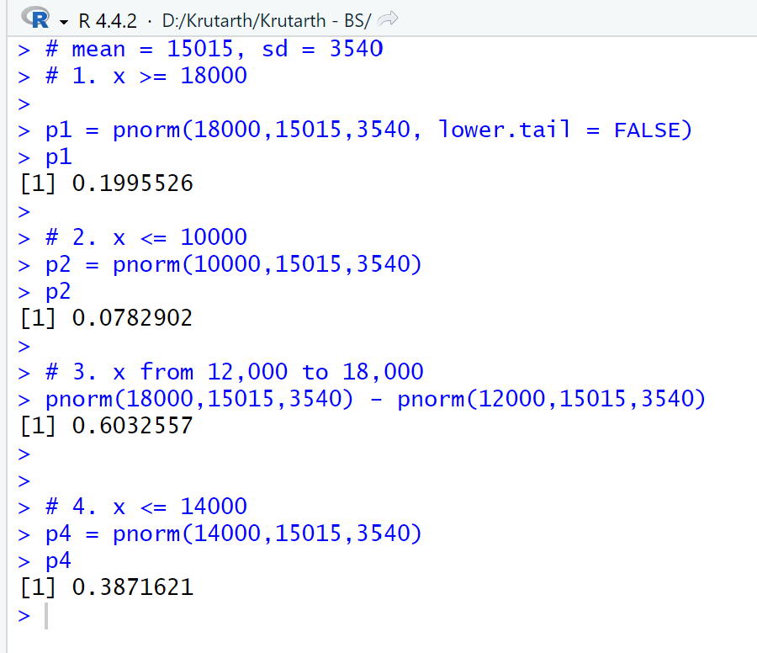

**Que-36 : The averagestock price for companies making up the S&P 500 is $30, and the standard de viation is $8.20 (BusinessWeek, Special Annual Issue, Spring 2003). Assume the stock prices are normally distributed. a. What is the probability a company will have a stock price of at least $40? b. What is the probability a company will have a stock price no higher than $20? c. How high does a stock price have to be to put a company in the top 10%?**

**Entry :**

# mean = 30, sd = 8.20

# 1. x >=40

pnorm(40,30,8.20, lower.tail = FALSE)

# 2. x <= 20

pnorm(20,30,8.20)

# 3. How high does a stock price have to be to put a company in the top 10%?

qnorm(0.9, 30, 8.2)

qnorm(0.1, 30, 8.20, lower.tail = FALSE)

**Answer :**

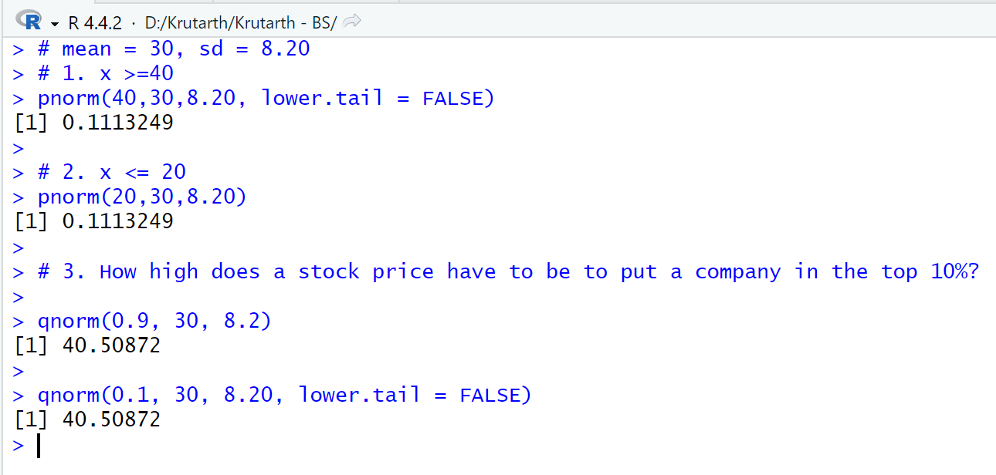

**Que-37 : In an article about the cost of health care, Money magazine reported that a visit to a hospi tal emergency room for something as simple as a sore throat has a mean cost of $328 (Money, January 2009). Assume that the cost for this type of hospital emergency room visit is normally distributed with a standard deviation of $92. Answer the following questions about the cost of a hospital emergency room visit for this medical service. a. What is the probability that the cost will be more than $500? b. What is the probability that the cost will be less than $250? c. What is the probability that the cost will be between $300 and $400? d. If the cost to a patient is in the lower 8% of charges for this medical service, what was the cost of this patient’s emergency room visit?**

**Entry :**

# mean=328, sd=92

# 1. x >= 500

pnorm(500,328,92, lower.tail = FALSE)

# 2. x <= 250

pnorm(250,328,92)

# 3. x from 300 to 400

pnorm(400,328,92) - pnorm(300,328,92)

# 4. If the cost to a patient is in the lower 8% of charges for this medical service, what was

# the cost of this patient’s emergency room visit?

qnorm(0.08,328,92)

**Answer :**

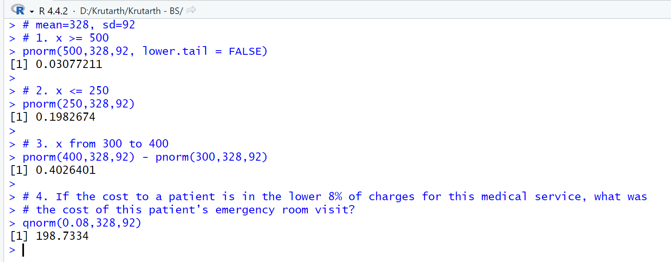

**Que-38 : In January 2003, the American worker spent an average of 77 hours logged on to the Inter net while at work (CNBC, March 15, 2003). Assume the population mean is 77 hours, the times are normally distributed, and that the standard deviation is 20 hours. a. What is the probability that in January 2003 a randomly selected worker spent fewer than 50 hours logged on to the Internet? b. What percentage of workers spent more than 100 hours in January 2003 logged on to the Internet? c. Aperson is classified as a heavy user if he or she is in the upper 20% of usage. In January 2003, how many hours did a worker have to be logged on to the Internet to be considered a heavy user?**

**Entry :**

# mean=77, sd=20

# 1. x < 50

pnorm(50,77,20)

# 2. x >= 100

p2 = pnorm(100,77,20, lower.tail = FALSE)

p = p2*100

p

# 3. A person is classified as a heavy user if he or she is in the upper 20% of usage. In

# January 2003, how many hours did a worker have to be logged on to the Internet to

# be considered a heavy user?

qnorm(0.8,77,20)

qnorm(0.2,77,20, lower.tail = FALSE)

**Answer :**

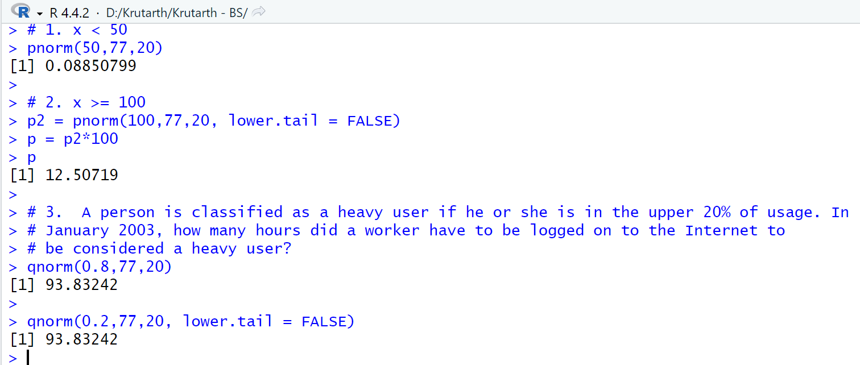

**Que-39 : Aperson must score in the upper 2% of the population on an IQ test to qualify for mem bership in Mensa, the international high-IQ society (U.S. Airways Attaché, September 2000). If IQ scores are normally distributed with a mean of 100 and a standard deviation of 15, what score must a person have to qualify for Mensa?**

**Entry :**

# mean=100, sd=15, x = 0.98

qnorm(0.98,100,15)

qnorm(0.02,100,15, lower.tail = FALSE)

**Answer :**

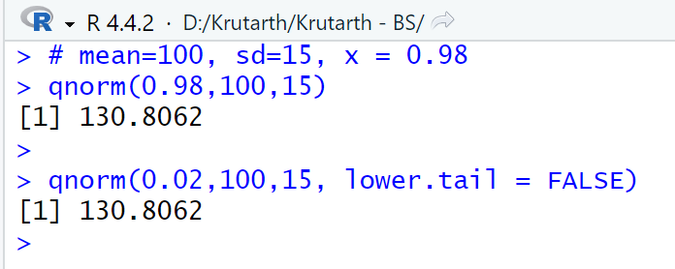

**Que-40 : The mean hourly pay rate for financial managers in the East North Central region is $32.62, and the standard deviation is $2.32 (Bureau of Labor Statistics, September 2005). Assume that pay rates are normally distributed. a. What is the probability a financial manager earns between $30 and $35 per hour? b. How high must the hourly rate be to put a financial manager in the top 10% with re spect to pay? c. For a randomly selected financial manager, what is the probability the manager earned less than $28 per hour?**

**Entry :**

# mean=32.62, sd=2.32

# 1. x from 30 to 35

pnorm(35,32.62,2.32) - pnorm(30,32.62,2.32)

# 2. top 10%

qnorm(0.9,32.62,2.32)

qnorm(0.1,32.62,2.32,lower.tail = FALSE)

# 3. x < 28

pnorm(28,32.62,2.32)

**Answer :**

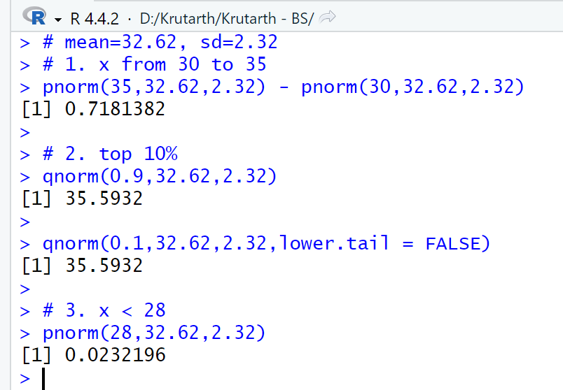

**Que-41 : The time needed to complete a final examination in a particular college course is normally distributed with a mean of 80 minutes and a standard deviation of 10 minutes. Answer the following questions. a. What is the probability of completing the exam in one hour or less? b. What is the probability that a student will complete the exam in more than 60 minutes but less than 75 minutes? c. WEB file Volume Assume that the class has 60 students and that the examination period is 90 minutes in length. How many students do you expect will be unable to complete the exam in the allotted time?**

**Entry :**

# mean=80, sd=10

# 1. x <= 60

pnorm(60,80,10)

# 2. x from 60 to 75

pnorm(75,80,10) - pnorm(60,80,10)

# 3. x = 60

p3 = pnorm(90,80,10, lower.tail = FALSE)

p=60*p3

p

**Answer :**

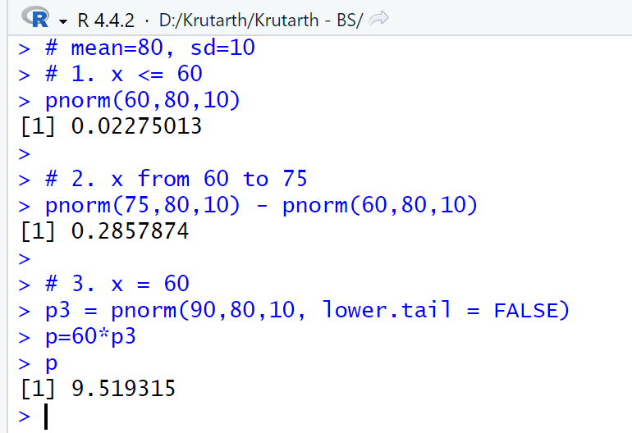

**Que-42 : Trading volume on the New York Stock Exchange is heaviest during the first half hour (early morning) and last half hour (late afternoon) of the trading day. The early morning trading volumes (millions of shares) for 13 days in January and February are shown here (Barron’s, January 23, 2006; February 13, 2006; and February 27, 2006). 214 202 174 163 198 171 265 212 211 194 201 211 180 The probability distribution of trading volume is approximately normal. a. Compute the mean and standard deviation to use as estimates of the population mean and standard deviation. b. What is the probability that, on a randomly selected day, the early morning trading vol ume will be less than 180 million shares? c. What is the probability that, on a randomly selected day, the early morning trading vol ume will exceed 230 million shares? d. How many shares would have to be traded for the early morning trading volume on a particular day to be among the busiest 5% of days?**

**Entry :**

x = c(214,202,174,163,198,171,265,212,211,194,201,211,180)

x

mean(x)

sd(x)

# mean=199.69, sd = 26.03

# 1. x < 180

pnorm(180,199.69,26.03)

# 2. x >= 230

pnorm(230,199.69,26.03, lower.tail = FALSE)

# 3. 5%

qnorm(0.95,199.69,26.03)

p3 = qnorm(0.05,199.69,26.03,lower.tail = FALSE)

p3

p = p3*100

p

**Answer :**

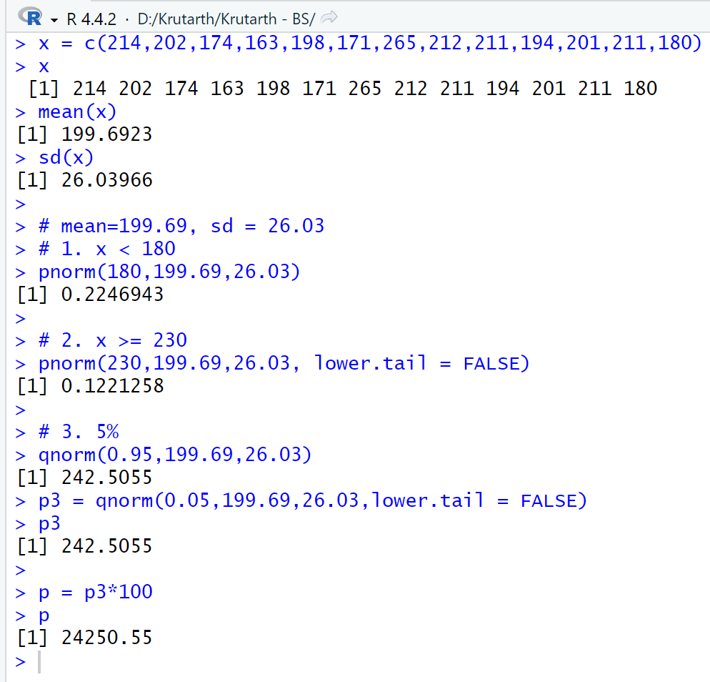

**Que-43 : According to the Sleep Foundation, the average night’s sleep is 6.8 hours (Fortune, March 20, 2006). Assume the standard deviation is .6 hours and that the probability distribution is normal. a. What is the probability that a randomly selected person sleeps more than 8 hours? b. What is the probability that a randomly selected person sleeps 6 hours or less? c. Doctors suggest getting between 7 and 9 hours of sleep each night. What percentage of the population gets this much sleep?**

**Entry :**

# mean=6.8, sd=0.6

# 1. x >= 8

pnorm(8,6.8,0.6,lower.tail = FALSE)

# 2. x <= 6

pnorm(6,6.8,0.6)

# 3. x from 7 to 9

p3 = pnorm(9,6.8,0.6) - pnorm(7,6.8,0.6)

p3

p = p3*100

p

**Answer :**

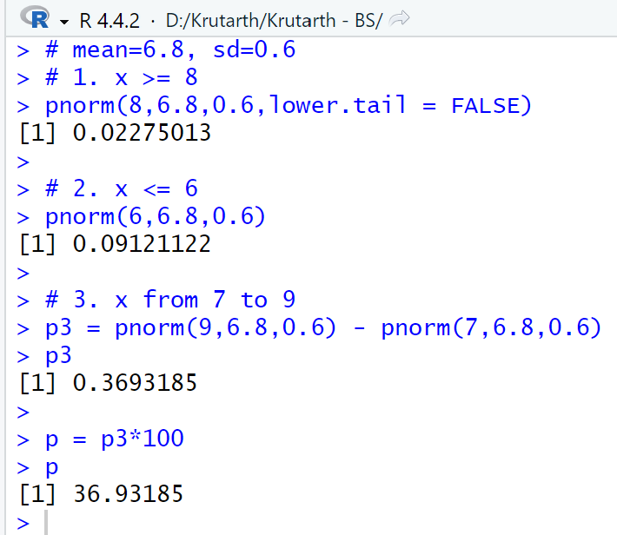

**Que-44 : generate sample data from the vector.**

**Entry :**

x = c(23,45,21,34,5,6,7,8,86,45,3)

x

set.seed(1)

x1=sample(x,5,replace = FALSE)

x1

y=c(1:100)

y

set.seed(2)

y1=sample(y,30,replace = FALSE)

y1

**Answer :**

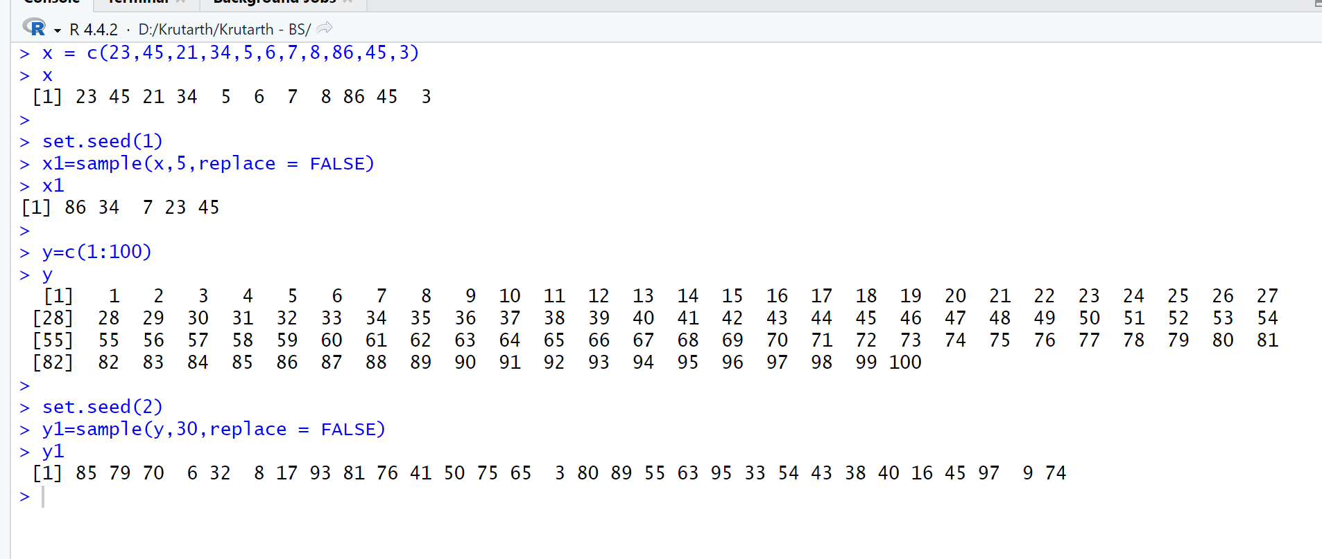

**Que-45 :**

**Entry :**

x = c(23,45,21,34,5,6,7,8,86,45,3)

x

#set.seed(1)

x1=sample(x,10,replace = TRUE)

x1

y=c(1:100)

y

set.seed(2)

y1=sample(y,30,replace = FALSE)

y1

#===============================================

data = c(23,45,21,34,5)

# get 10 random elements with probabillity

print(sample(data, size = 10, replace = TRUE, prob = c(0.6,0.1,0.1,0.1,0.1)))

# consider the vector

data1 = c(23,45,21,34,5,6,7,8,86,45,3)

# get 20 random elements with probabillity

print(sample(data1, size = 20, replace = TRUE, prob = c(0.1,0.05,0.1,0.05,0.15,0.05,0.1,0.1,0.1,0.1,0.1)))

mean(data1)

# xbar = sample mean, miu = population mean, s = sample sd, sigma = population sd, n = sample size

**Answer :**

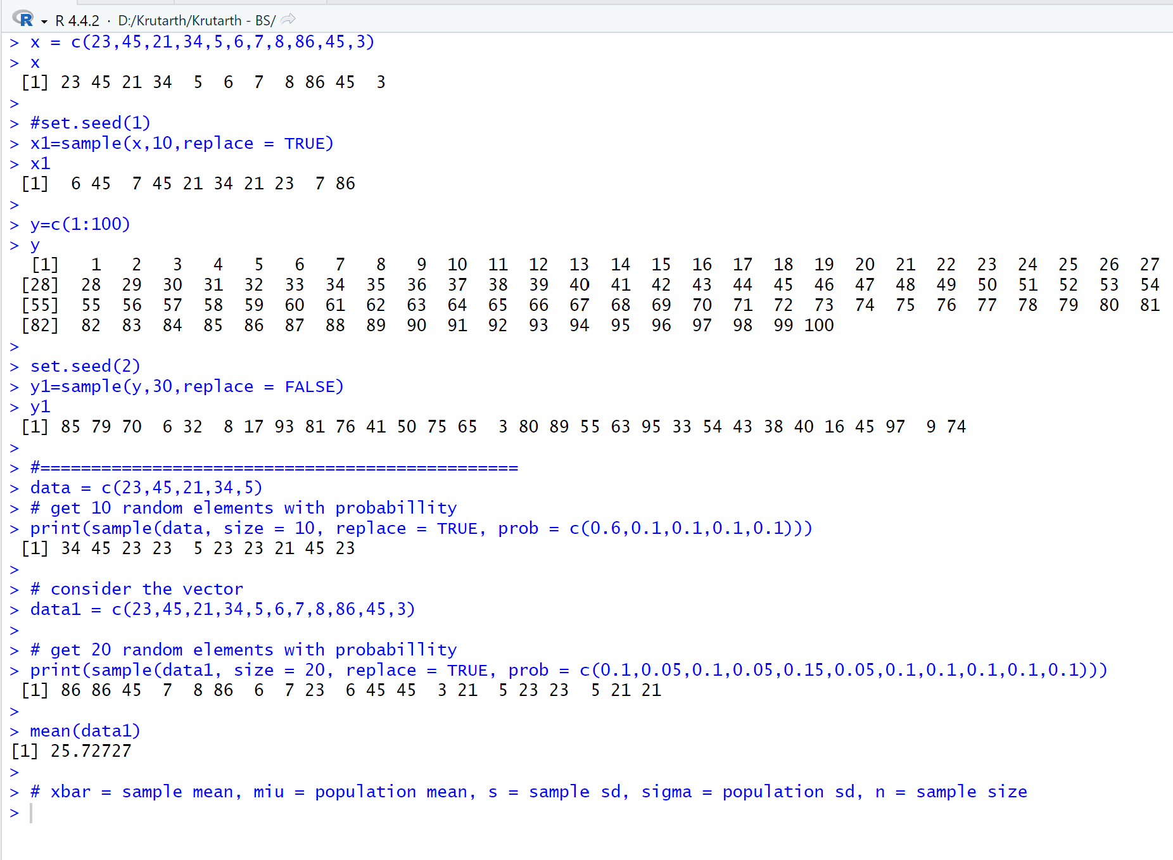

**Que-46 :**

**Entry :**

n=50

s=6

mx=32

#for 90% conf.interval

z1=qnorm(0.95)

me=z1*s/sqrt(n)

me

ci=c(mx-me,mx+me)

ci

#for 95% conf.interval

z2=qnorm(0.975)

me=z2*s/sqrt(n)

me

c2=c(mx-me,mx+me)

c2

**Answer :**

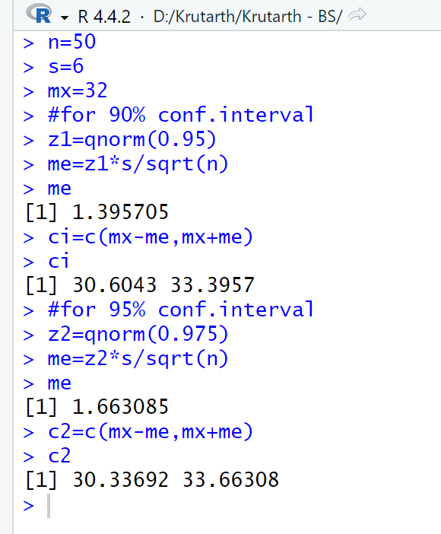

**Que-47 :**

**Entry :**

n=49

s=5

mx=24.8

#for 95% c interval

z1=qnorm(0.975)

me=z1*s/sqrt(n)

c1=c(mx-me,mx+me)

c1

**Answer :**

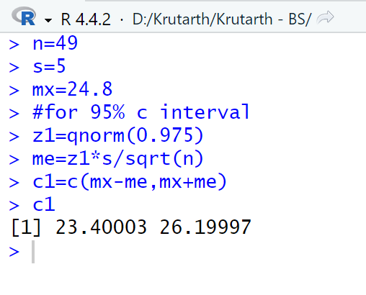

**Que-48 :**

**Entry :**

mx=1599

n=50

s=600

#for 95% com interva

z1=qnorm(0.975)

me=z1*s/sqrt(n)

me

c1=c(mx-me,mx+me)

c1

**Answer :**

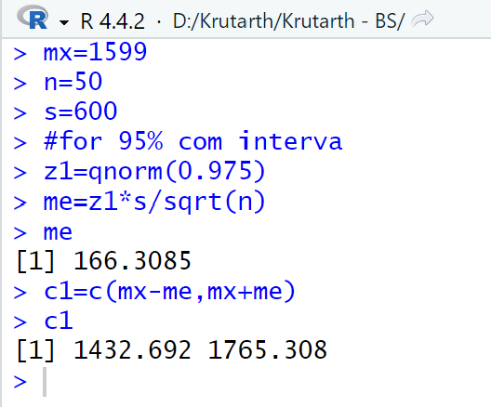

**Que-49 : # obtain when sd is not given.**

**# For a random sample of 36 items and a sample mean of 211, compute a 95%**

**# confidence interval of mean if the population standard deviation is 23.**

**Entry :**

n=36

xbar=211

s=23

ztab=qnorm(0.975)

ztab

me=ztab*s/sqrt(n)

me

ci=c(xbar-me,xbar+me)

ci

**Answer :**

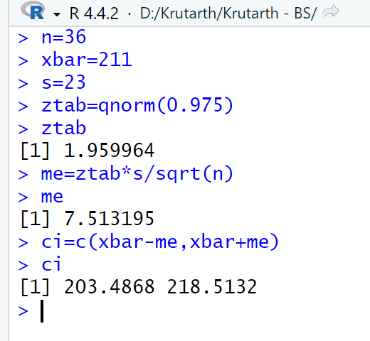

**Que-50 : Write a program in R to generate population of 100 random numbers. Take 80**

**# samples out of population and calculate 95% confidence interval.**

**Entry :**

x=c(1:100)

set.seed(1)

x1=sample(x,80)

x1

n=length(x1)

s=sd(x)

xbar=mean(x1)

ztab=qnorm(0.975)

me=ztab*s/sqrt(n)

me

ci=c(xbar-me,xbar+me)

ci

**Answer :**

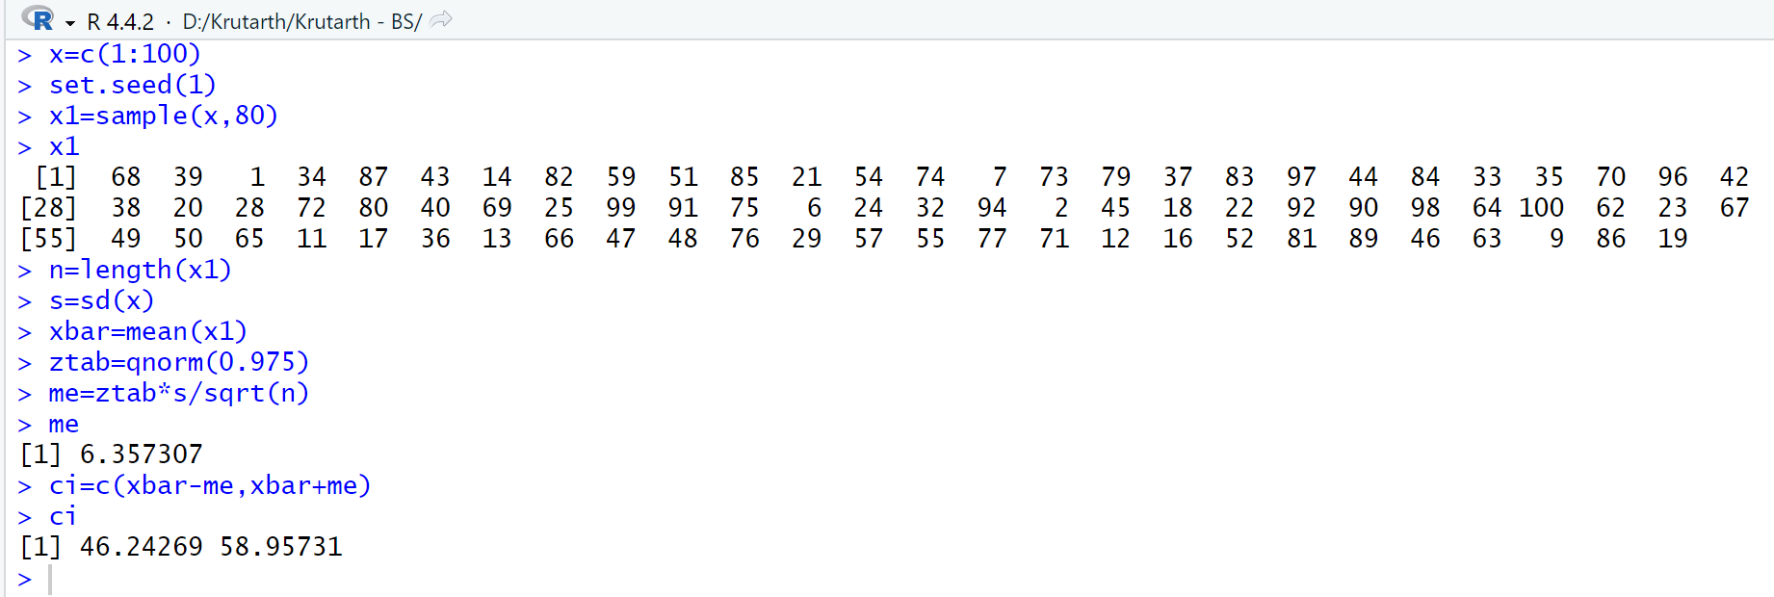

**Que-51 : Write a program in R to calculate 88% confidence interval µ=5, sd=2 and n=20.**

**Entry :**

n=20

sd=2

xbar=5

ztab=qnorm(0.94)

ztab

me=ztab*sd/sqrt(n)

me

ci=c(xbar-me,xbar+me)

ci

**Answer :**

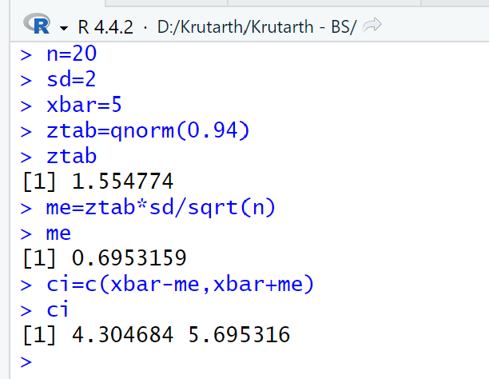

**Que-52 : Write a program in R to generate 36 random samples and calculate 90%, 95% and 99% confidence interval.**

**Entry :**

x=c(1:100)

set.seed(2)

x1=sample(x,36)

x1

n=length(x1)

s=sd(x)

sd=

xbar=5

ztab=qnorm(0.975)

ztab

me=ztab*sd/sqrt(n)

me

ci=c(xbar-me,xbar+me)

ci

**Answer :**

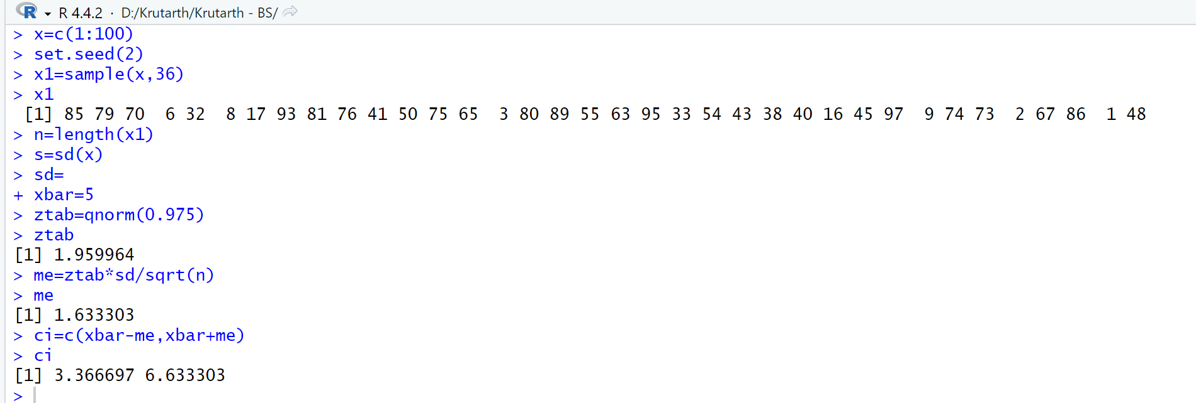

**Que-53 : #For random samples of 18 managers and measures the amount of extra time they work**

**#during a specific week and obtains the results shown below**

**#6,21,17,20,7,0,8,16,29,3,8,12,11,9,21,25,15,16**

**#Construct 90% confidence interval to estimate the average amount of extra time per**

**#week worked by manager.**

**Entry :**

x=c(6,21,17,20,7,0,8,16,29,3,8,12,11,9,21,25,15,16)

x

xbar=mean(x)

s=sd(x)

n=length(x)

ttab=qt(0.95,n-1)

me=ttab*s/sqrt(n)

me

ci=c(xbar-me, xbar+me)

ci

print(paste("The 90% conf. Interval is ", ci))

**Answer :**

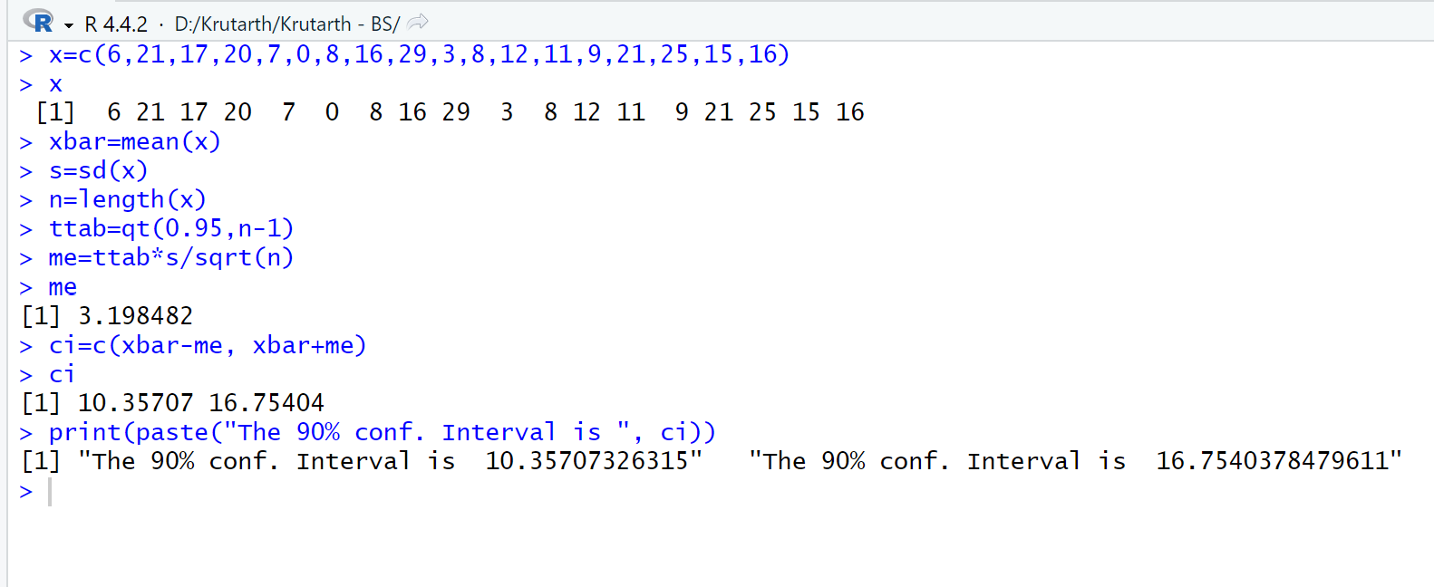

**Que-54 : #Suppose the following data are normally selected from a population of normally**

**#distributed values**

**#50,40,51,43,48,44,57,54,47,39,42,48,45,39,43,46**

**#Construct a 95% confidence interval to estimate the population mean.**

**Entry :**

x=c(50,40,51,43,48,44,57,54,47,39,42,48,45,39,43,46)

x

xbar=mean(x)

s=sd(x)

n=length(x)

ttab=qt(0.975,n-1)

me=ttab*s/sqrt(n)

me

ci=c(xbar-me, xbar+me)

ci

print(paste("The 95% conf. Interval is ", ci))

t.test(x,conf.level = 0.95)

**Answer :**

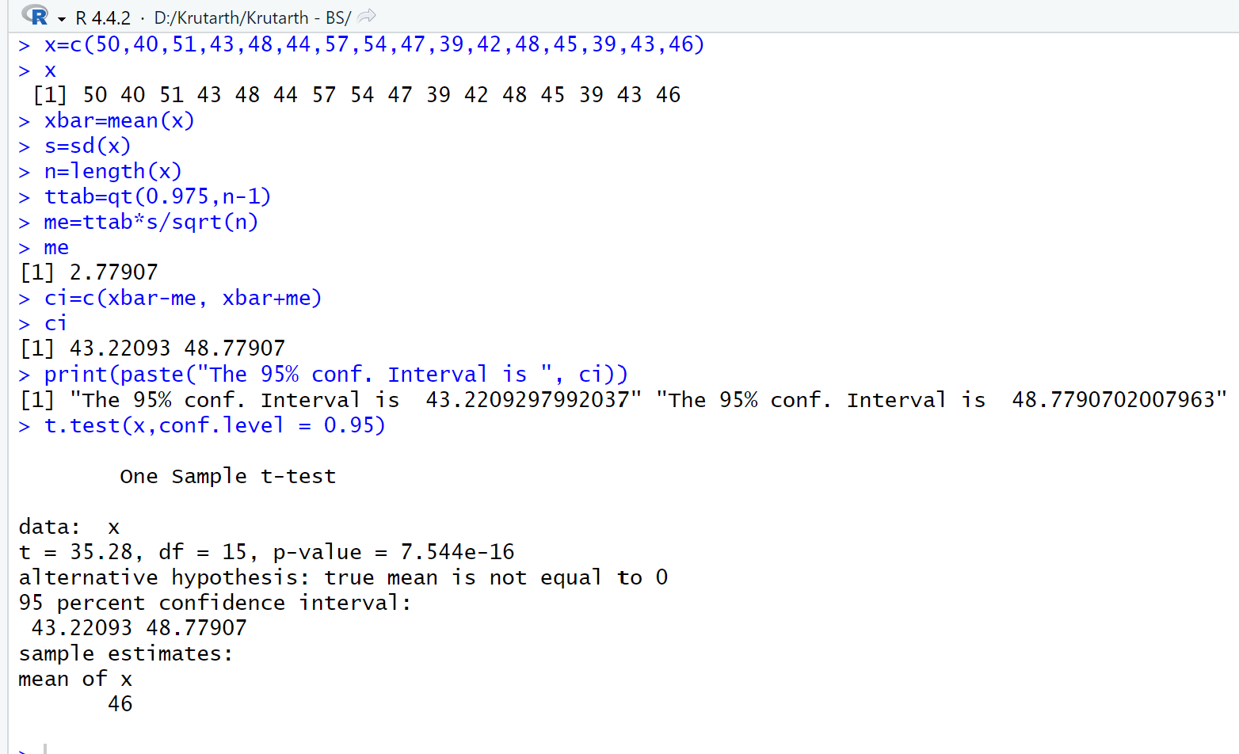

**Que-55 : #Write a program in R to create a vector**

**#(1,21,17,20,7,0,8,16,29,3,8,12,11,9,21,25,15,16) and calculate 88% interval estimate using t distribution.**

**Entry :**

x=c(1,21,17,20,7,0,8,16,29,3,8,12,11,9,21,25,15,16)

x

xbar=mean(x)

s=sd(x)

n=length(x)

ttab=qt(0.94,n-1)

me=ttab*s/sqrt(n)

me

ci=c(xbar-me, xbar+me)

ci

print(paste("The 88% conf. Interval is ", ci))

t.test(x,conf.level = 0.88)

**Answer :**

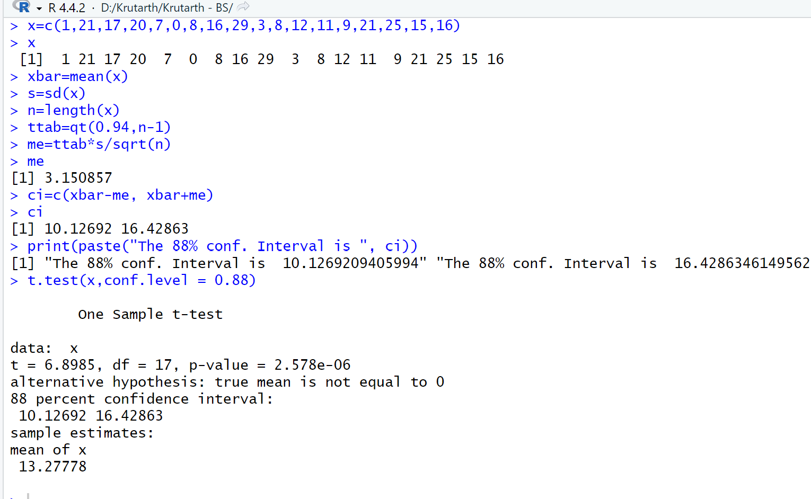

**Que-56 : The International Air Transport Association surveys business travelers to develop quality ratings for transatlantic gateway airports. The maximum possible rating is 10. Suppose a simple random sample of 50 business travelers is selected and each traveler is asked to provide a rating for the Miami International Airport. The ratings obtained from the sample of 50 business travelers follow Develop a 95% confidence interval estimate of the population mean rating for Miami.**

**Entry :**

data1 = read.csv("D:\\Krutarth\\Krutarth - BS\\que-52.csv",header = TRUE)

x=data1$x

x

xbar=mean(x)

s=sd(x)

n=length(x)

ttab=qt(0.975,n-1)

me=ttab*s/sqrt(n)

me

ci=c(xbar-me, xbar+me)

ci

print(paste("The 95% conf. Interval is ", ci))

t.test(x,conf.level = 0.95)

**Answer :**

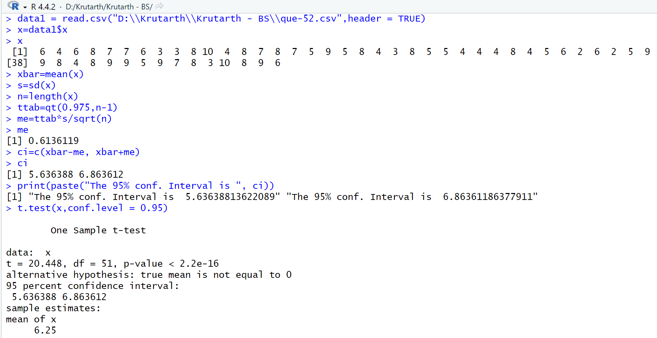

**Que-57 : Fowle Marketing Research, Inc., bases charges to a client on the assumption that telephone**

**surveys can be completed in a mean time of 15 minutes or less. If a longer mean survey**

**time is necessary, a premium rate is charged. A sample of 35 surveys provided the survey**

**times shown in the file named Fowle. Based upon past studies, the population standard**

**deviation is assumed known with σ**

**4 minutes. Is the premium rate justified?**

**a.Formulate the null and alternative hypotheses for this application.**

**b. Compute the value of the test statistic.**

**c.What is the p-value?**

**d. At α .01, what is your conclusion?**

**Entry :**

data1 = read.csv("D:\\Krutarth\\Krutarth - BS\\que-53.csv", header = TRUE)

data1

x=data1$x

x

miu = 15

xbar =mean(x)

n = length(x)

sigma = 4

alpha= 0.01

# H0 : miu = 15, miu not equals to 15

diff = xbar - miu

se = sigma/sqrt(n)

zcal = diff/se

ztab = qnorm(1-alpha/2)

zcal

ztab

if(zcal > ztab)print(paste(" Here zcal is greater than ztab so H0 is Rejected")) else print(paste(" H0 is accepted"))

# critical value method

me=ztab*se

ci=c(xbar-me, xbar+me)

ci

lm1=xbar-me

lm2=xbar+me

if((miu < lm1) || (miu > lm2)) print(paste(" H0 is Rejected")) else print(paste(" H0 is accepted"))

# p-value method

pvalue=pnorm(zcal,lower.tail = FALSE)

if(pvalue > (alpha/2)) print(paste(" H0 is accepted")) else print(paste(" H0 is Rejected"))

**Answer :**

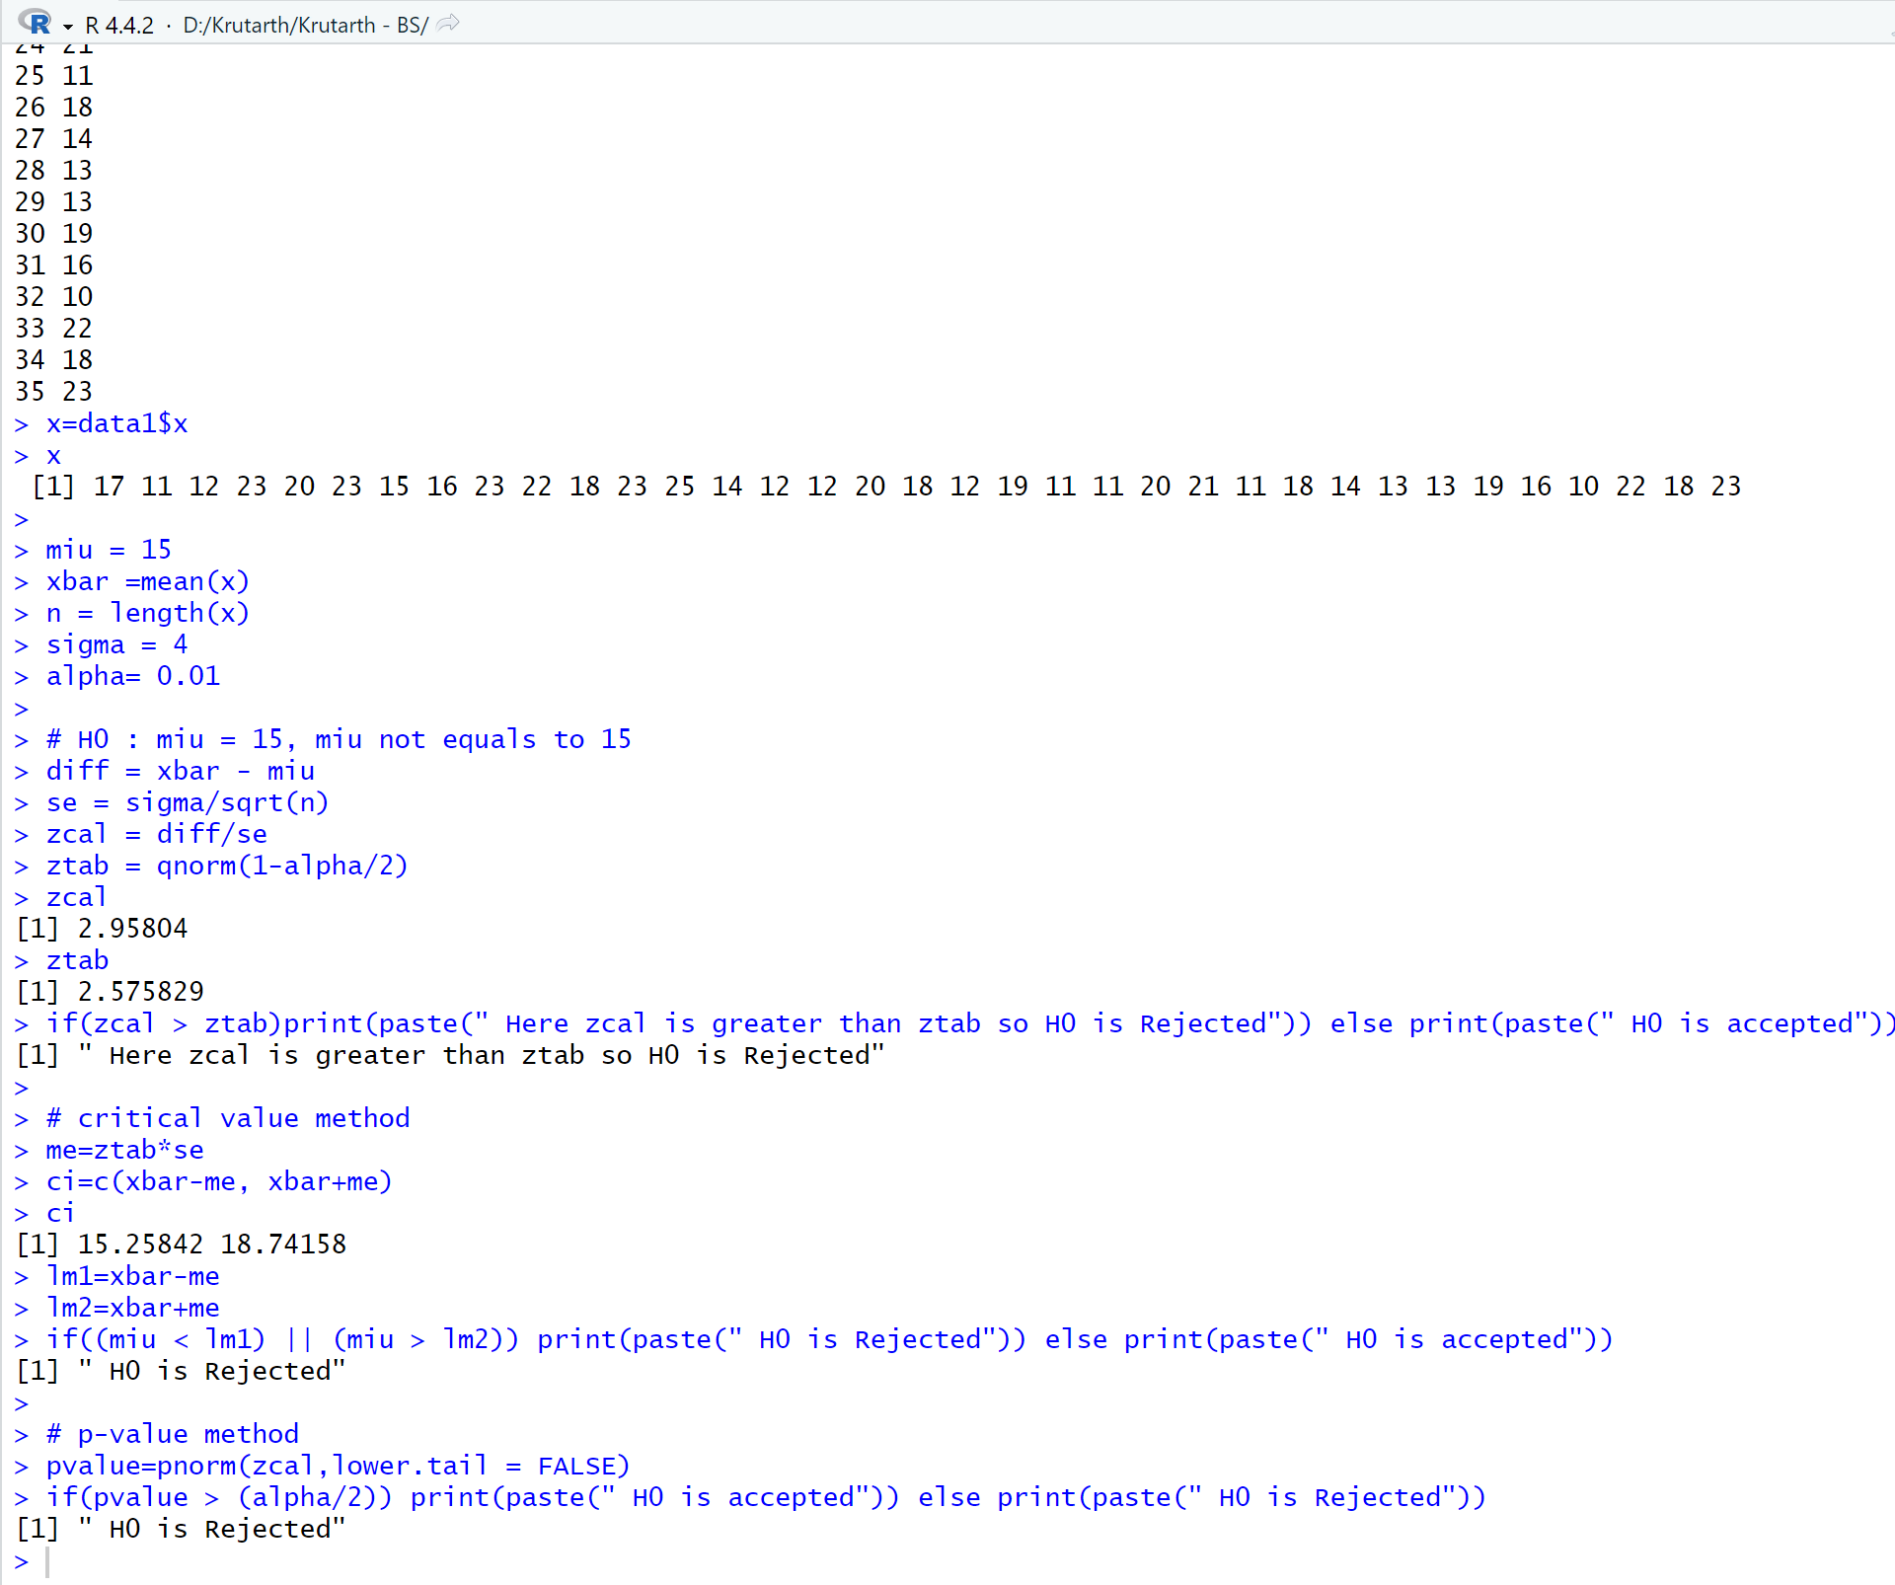

**Que-58 : Write a program in R to test null hypothesis using Z test where populations mean=3,**

**σ = 2 and sample given is (3, 7, 11, 0, 7, 0, 4, 5, 6, 2). If null hypothesis is H0 :**

**sample mean=3, what is your conclusion.**

**Entry :**

x=c(3, 7, 11, 0, 7, 0, 4, 5, 6, 2)

miu = 3

xbar =mean(x)

n = length(x)

sigma = 2

alpha= 0.05

# H0 : miu = 3, miu not equals to 3

diff = xbar - miu

se = sigma/sqrt(n)

zcal = diff/se

ztab = qnorm(1-alpha/2)

zcal

ztab

if(zcal > ztab)print(paste(" Here zcal is greater than ztab so H0 is Rejected")) else print(paste(" H0 is accepted"))

# critical value method

me=ztab*se

ci=c(xbar-me, xbar+me)

ci

lm1=xbar-me

lm2=xbar+me

if((miu < lm1) || (miu > lm2)) print(paste(" H0 is Rejected")) else print(paste(" H0 is accepted"))

# p-value method

pvalue=pnorm(zcal,lower.tail = FALSE)

if(pvalue > (alpha/2)) print(paste(" H0 is accepted")) else print(paste(" H0 is Rejected"))

**Answer :**

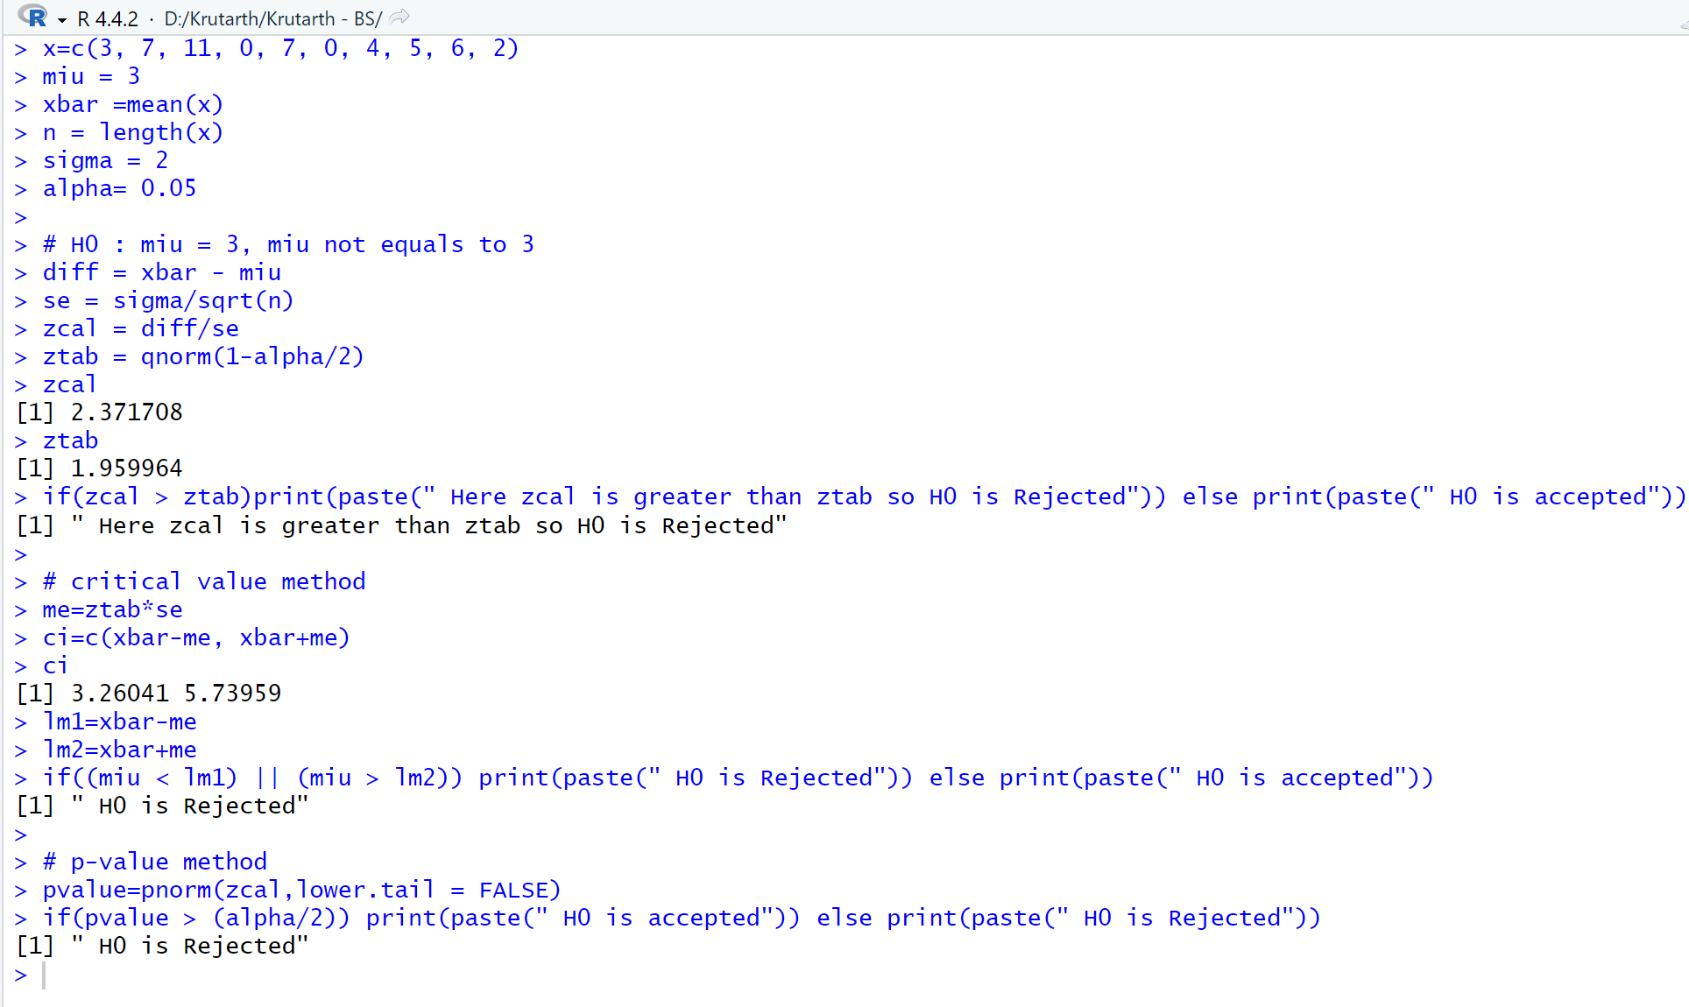

**Que-59 : Consider the following hypothesis test:**

**H 0 : sample mean=15, H a : sample mean≠15**

**A sample of 50 provided a sample mean of 14.15. The population standard deviation**

**is 3.**

**(1) Compute the value of the test statistic**

**(2) What is the p- value?**

**(3) At α=0.05, what is your conclusion?**

**(4) What is the rejection rule using the critical value? What is your conclusion?**

**Entry :**

miu = 15

xbar = 14.15

n = 50

sigma = 3

alpha=0.05

# H0 : miu = 15, miu not equals to 15

diff = miu - xbar

se = sigma/sqrt(n)

zcal = diff/se

ztab = qnorm(1-alpha/2)

zcal

ztab

if(zcal > ztab)print(paste(" Here zcal is greater than ztab so H0 is Rejected")) else print(paste(" H0 is accepted"))

# critical value method

me=ztab*se

ci=c(xbar-me, xbar+me)

ci

lm1=xbar-me

lm2=xbar+me

if((miu < lm1) || (miu > lm2)) print(paste(" H0 is Rejected")) else print(paste(" H0 is accepted"))

# p-value method

pvalue=pnorm(zcal,lower.tail = FALSE)

if(pvalue > (alpha/2)) print(paste(" H0 is accepted")) else print(paste(" H0 is Rejected"))

**Answer :**

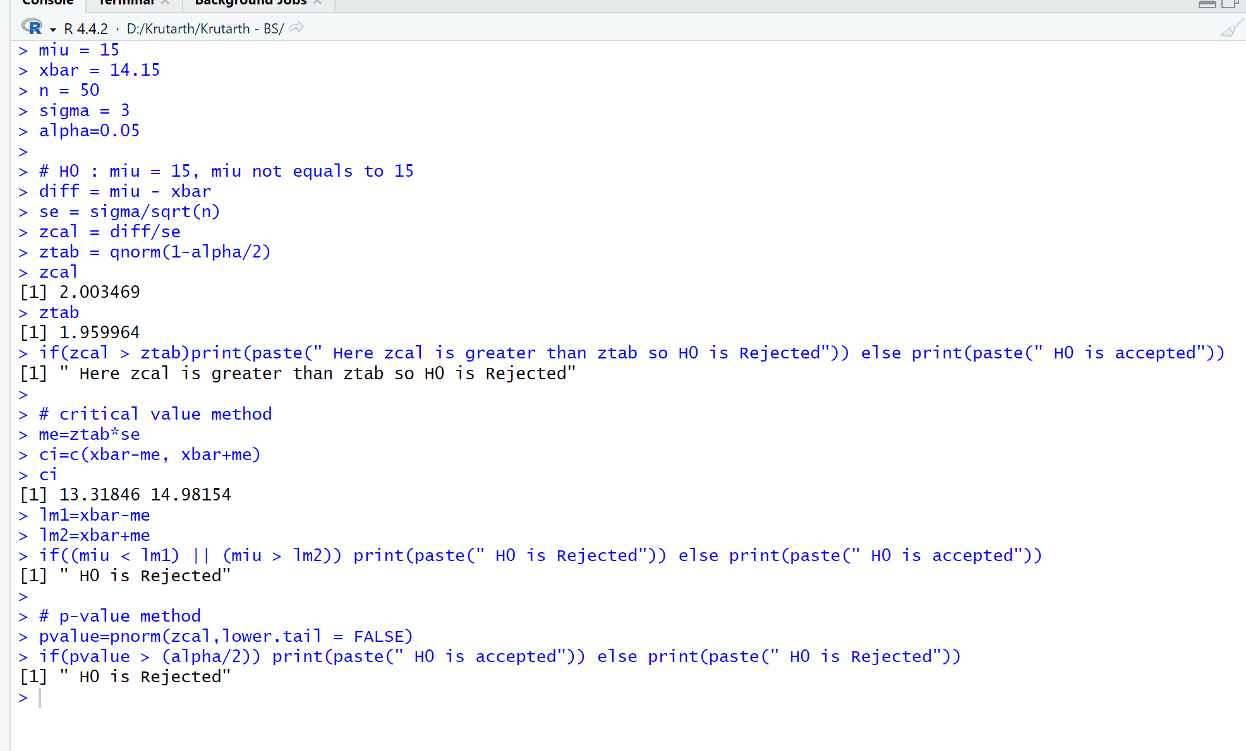

**Que-60 : According to the National Automobile Dealers Association, the mean price for used cars is $10,192. A manager of a Kansas City used car dealership reviewed a sample of 50 recent used car sales at the dealership in an attempt to determine whether the population mean price for used cars at this particular dealership differed from the national mean. The prices for the sample of 50 cars are shown in the file named Used Cars.**

**a.Formulate the hypotheses that can be used to determine whether a difference exists in the mean price for used cars at the dealership.**

**b. What is the p-value?**

**c.At α .05, what is your conclusion?**

**Entry :**

data1 = read.csv("D:\\Krutarth\\Krutarth - BS\\que-55.csv", header=TRUE)

data1

x=data1$Sale.Price

x

miu = 10192

xbar=mean(x)

s=sd(x)

n=length(x)

# H0 : miu = 10192, H1: miu not equals to 10192

xbar

diff=miu-xbar

se=s/sqrt(n)

se

tcal = diff/se

tcal

alpha=0.05

ttab = qt(1-alpha/2, n-1)

ttab

if(tcal > ttab) print(paste("Here tcal is greater than ttab so H0 is rejected")) else print(paste("Here tcal is less than ttab so H0 is accepted"))

me=ttab*se

ci=c(xbar-me, xbar+me)

ci

t.test(x)

**Answer :**

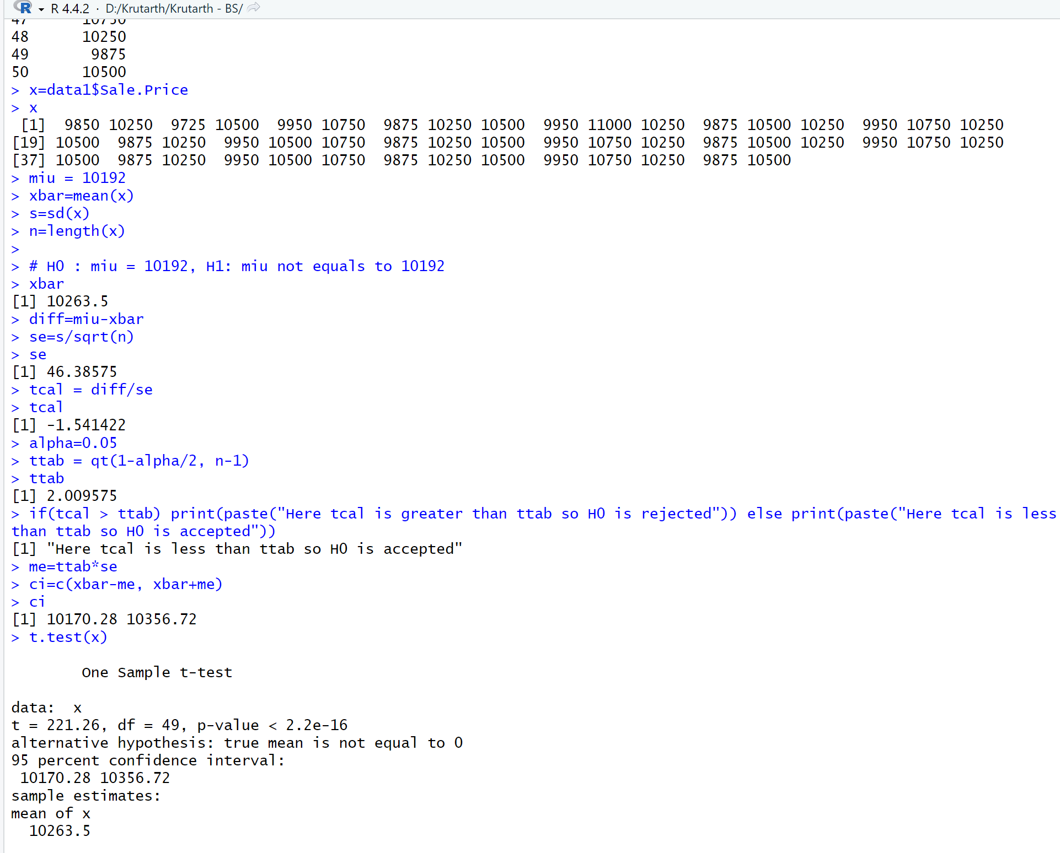

**Que-61 : Annual per capita consumption of milk is 21.6 gallons (Statistical Abstract of the United States: 2006). Being from the Midwest, you believe milk consumption is higher there and wish to support your opinion. A sample of 16 individuals from the midwestern town of Webster City showed a sample mean annual consumption of 24.1 gallons with a standarddeviation of s 4.8.**

**a.Develop a hypothesis test that can be used to determine whether the mean annualconsumption in Webster City is higher than the national mean.**

**b. What is a point estimate of the difference between mean annual consumption inWebster City and the national mean?**

**c.At α .05, test for a significant difference. What is your conclusion?**

**Entry :**

data1 = read.csv("D:\\Krutarth\\Krutarth - BS\\que-55-2.csv", header=TRUE)

data1

x=data1$x

x

miu = 21.6

xbar=24.1

s=4.8

n=16

# H0 : miu = 21.6, H1: miu > 21.6

xbar

diff=xbar-miu

se=s/sqrt(n)

se

tcal = diff/se

tcal

alpha=0.05

ttab = qt(1-alpha, n-1)

ttab

if(tcal > ttab) print(paste("Here tcal is greater than ttab so H0 is rejected")) else print(paste("Here tcal is less than ttab so H0 is accepted"))

me=ttab*se

ci=c(xbar-me, xbar+me)

ci

**Answer :**

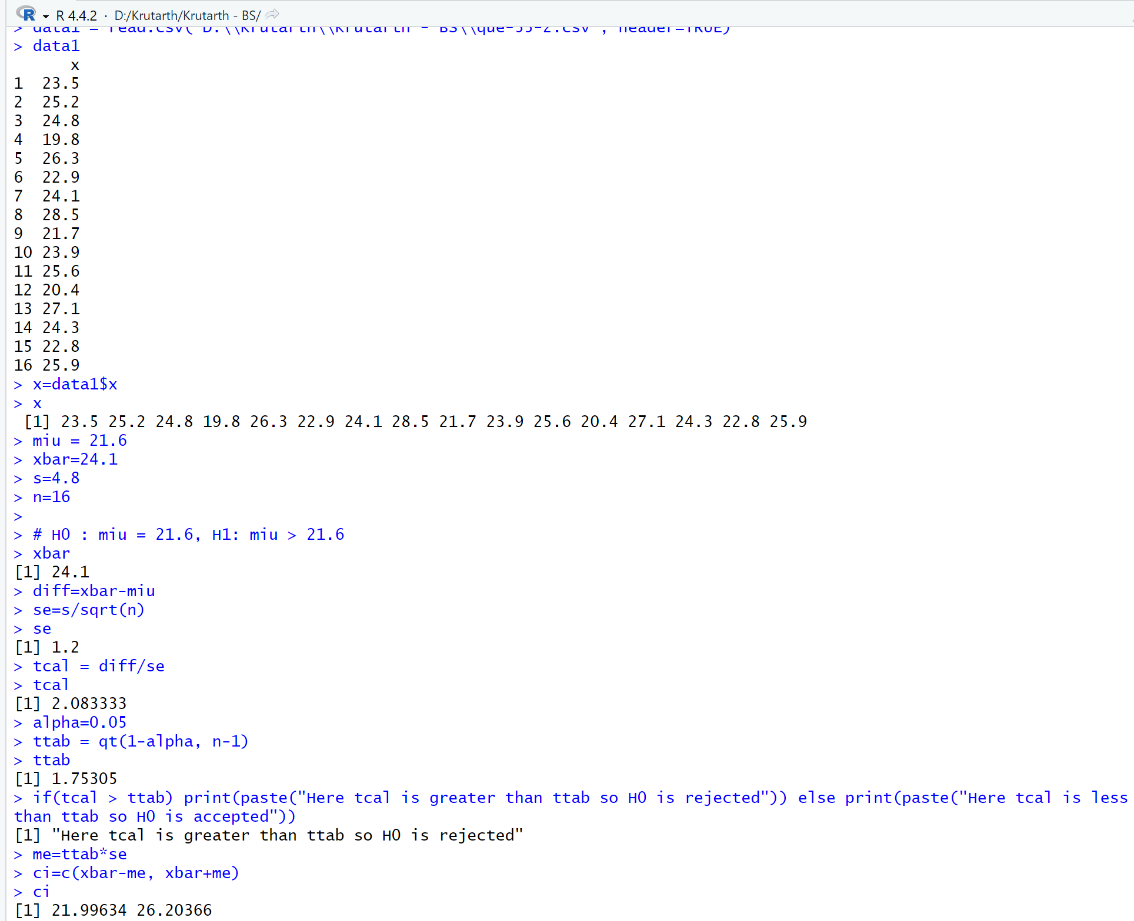

**Que-62 : The following data shows sales made by salespeople from two different cities.**

**City A: 59,68,44,71,63,46,69,54,48**

**City B : 50,36,62,52,70,41**

**Assuming the populations sampled to be approximately normal having the same variance, test whether there is any significant difference between the means of these samples.**

**Entry :**

x1=c(59,68,44,71,63,46,69,54,48)

x2=c(50,36,62,52,70,41)

x1bar = mean(x1)

x2bar = mean(x2)

n1 = length(x1)

n2 = length(x2)

s1 = sd(x1)

s2 = sd(x2)

x1bar

x2bar

#miu = miu2, h1: miu not equals to miu2

diff = x1bar - x2bar

se = sqrt(((s1^2)/n1) + ((s2^2)/n2))

se

tcal = diff/se

tcal

alpha = 0.05

ttab = qt(1-alpha/2, n1+n2-2)

ttab

if(tcal>ttab) print(paste(" here tcal is greater than ttab so h0 is rejected")) else print(paste(" here tcal is less than ttab so h0 is accepted"))

me = ttab*se

me

ci=c(diff-me,diff+me)

ci

t.test(x1,x2,conf.level = 0.95)

**Answer :**

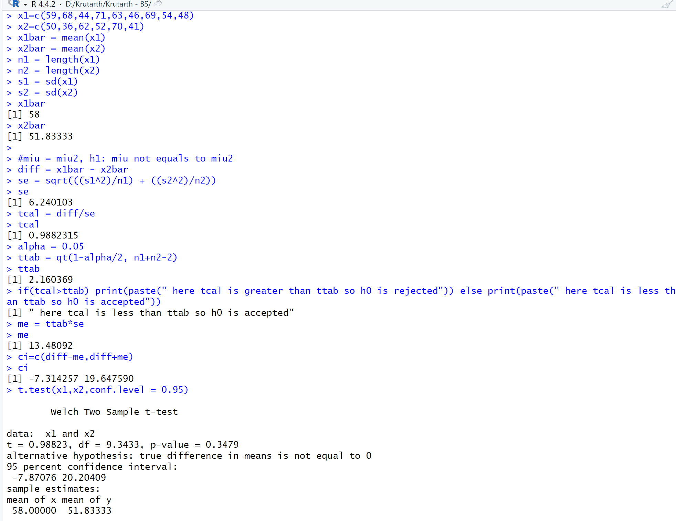

**Que-63 : Write a program in R to test null hypothesis using t test for given dataset at 95%**

**level of significance. Conclude your results.**

**Women’s Height 1.38, 1.26, 3.64, 3.50, 2.47, 3.21, 1.05, 1.98, 2.72**

**Men’s Height 2.48, 1.50, 4.59, 3.06, 2.11, 2.80, 1.59, 0.92, 0.47**

**Entry :**

x1=c(1.38,1.26,3.64,3.50,2.47,3.21,1.05,1.98,2.72)

x2=c(2.48,1.50,4.59,3.06,2.11,2.80,1.59,0.92,0.47)

x1bar = mean(x1)

x2bar = mean(x2)

n1 = length(x1)

n2 = length(x2)

s1 = sd(x1)

s2 = sd(x2)

x1bar

x2bar

#miu = miu2, h1: miu not equals to miu2

diff = x1bar - x2bar

se = sqrt(((s1^2)/n1) + ((s2^2)/n2))

se

tcal = diff/se

tcal

alpha = 0.02

ttab = qt(1-alpha/2, n1+n2-2)

ttab

if(tcal>ttab) print(paste(" here tcal is greater than ttab so h0 is rejected")) else print(paste(" here tcal is less than ttab so h0 is accepted"))

me = ttab*se

me

ci=c(diff-me,diff+me)

ci

t.test(x1,x2,conf.level = 0.98)

**Answer :**

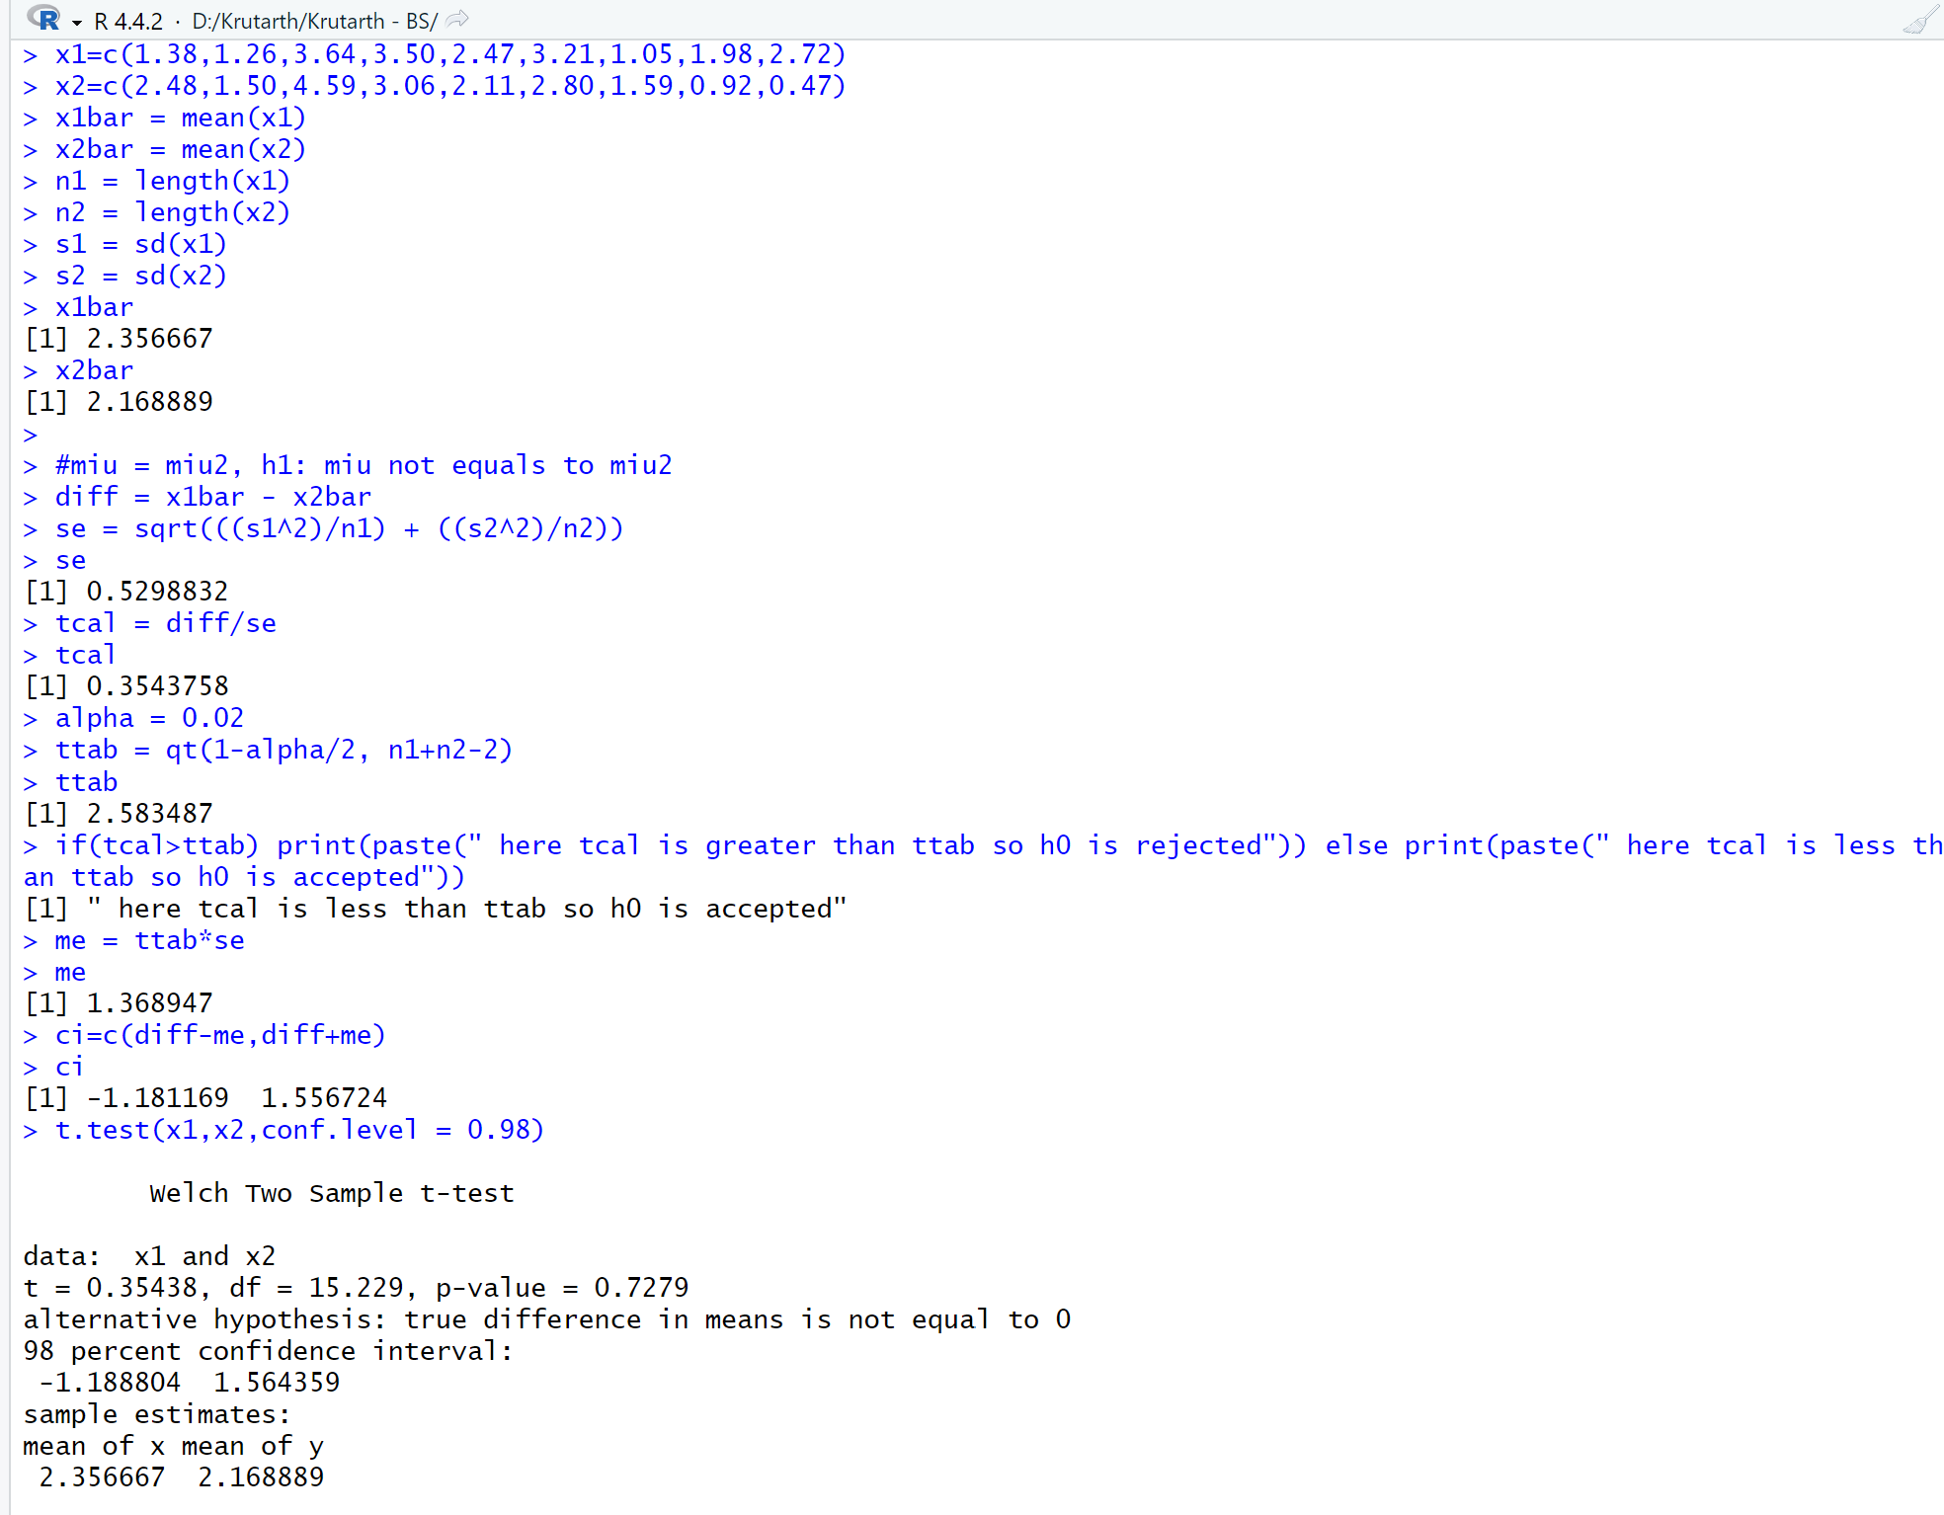

**Que-64 : Nine computer-components dealers in major metropolitan areas were asked for their**

**prices in $ on two similar colour inkjet printers. The results of this survey are given**

**below. At α = 0.05, is it reasonable to assert that, on average, the Apson printer is**

**less expensive than the Okaydata printer? (Write a program in R)**

**Dealer 1 2 3 4 5 6 7 8 9**

**Apson 250, 319, 285, 260, 305, 295, 289, 309, 275**

**Okaydata 270, 325, 269, 275, 289, 285, 295, 325, 300**

**Entry :**

x1=c(250, 319, 285, 260, 305, 295, 289, 309, 275)

x2=c(270, 325, 269, 275, 289, 285, 295, 325, 300)

x1bar = mean(x1)

x2bar = mean(x2)

n1 = length(x1)

n2 = length(x2)

s1 = sd(x1)

s2 = sd(x2)

x1bar

x2bar

#miu = miu2, h1: miu not equals to miu2

diff = x2bar - x1bar

se = sqrt(((s1^2)/n1) + ((s2^2)/n2))

se

tcal = diff/se

tcal

alpha = 0.05

ttab = qt(1-alpha/2, n1+n2-2)

ttab

if(tcal>ttab) print(paste(" here tcal is greater than ttab so h0 is rejected")) else print(paste(" here tcal is less than ttab so h0 is accepted"))

me = ttab*se

me

ci=c(diff-me,diff+me)

ci

t.test(x1,x2,conf.level = 0.95)

**Answer :**

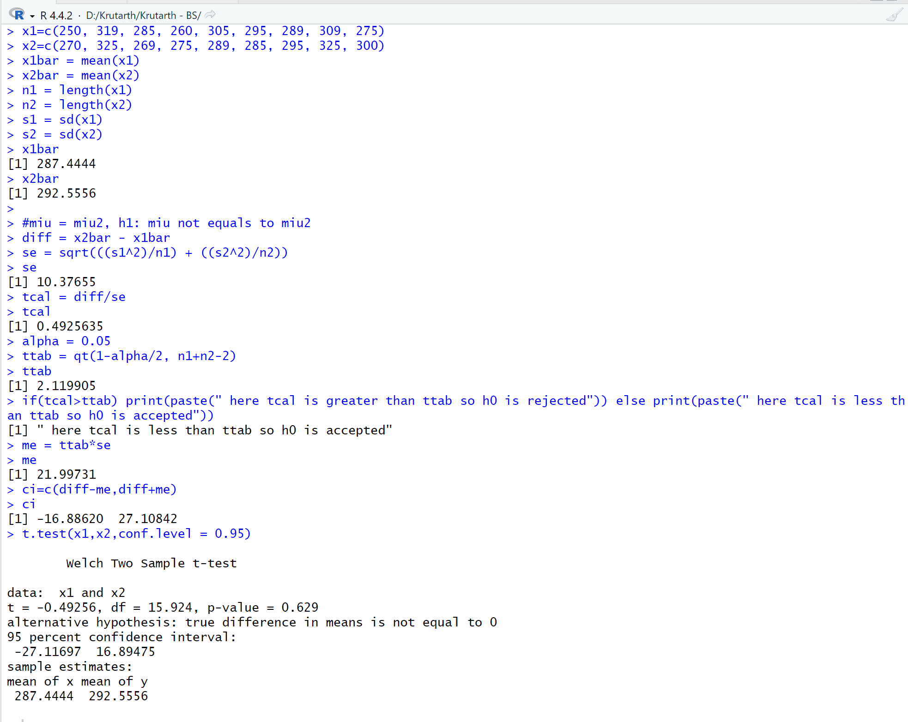

**Que-65 :**

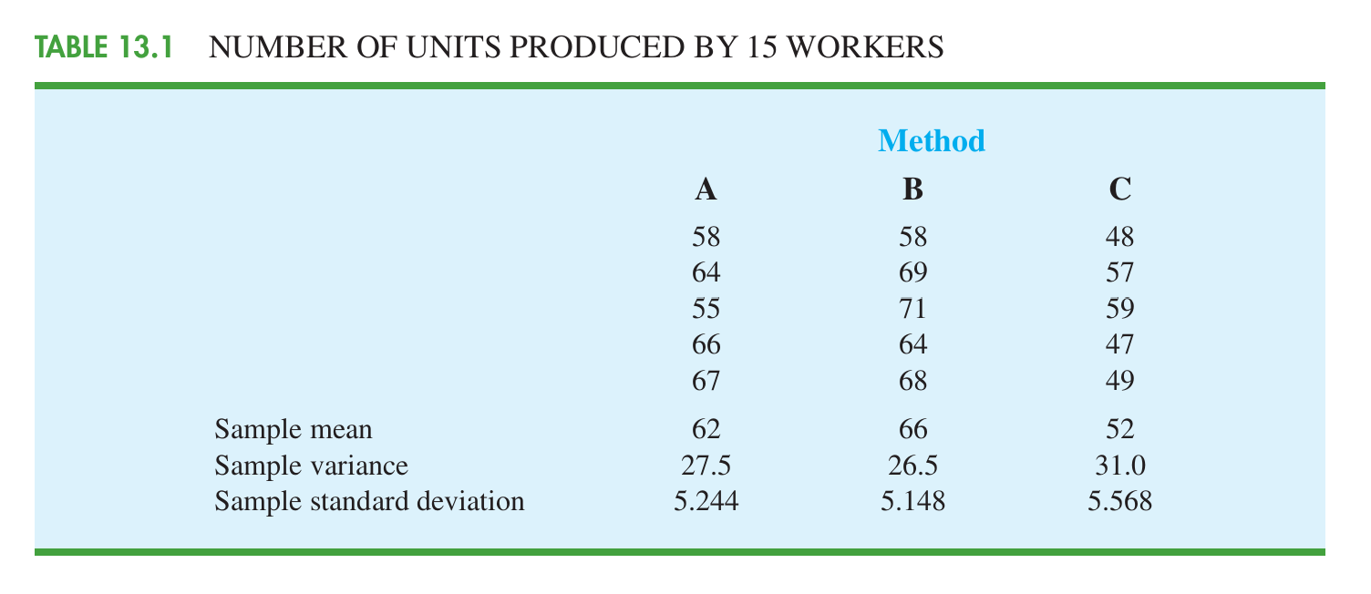

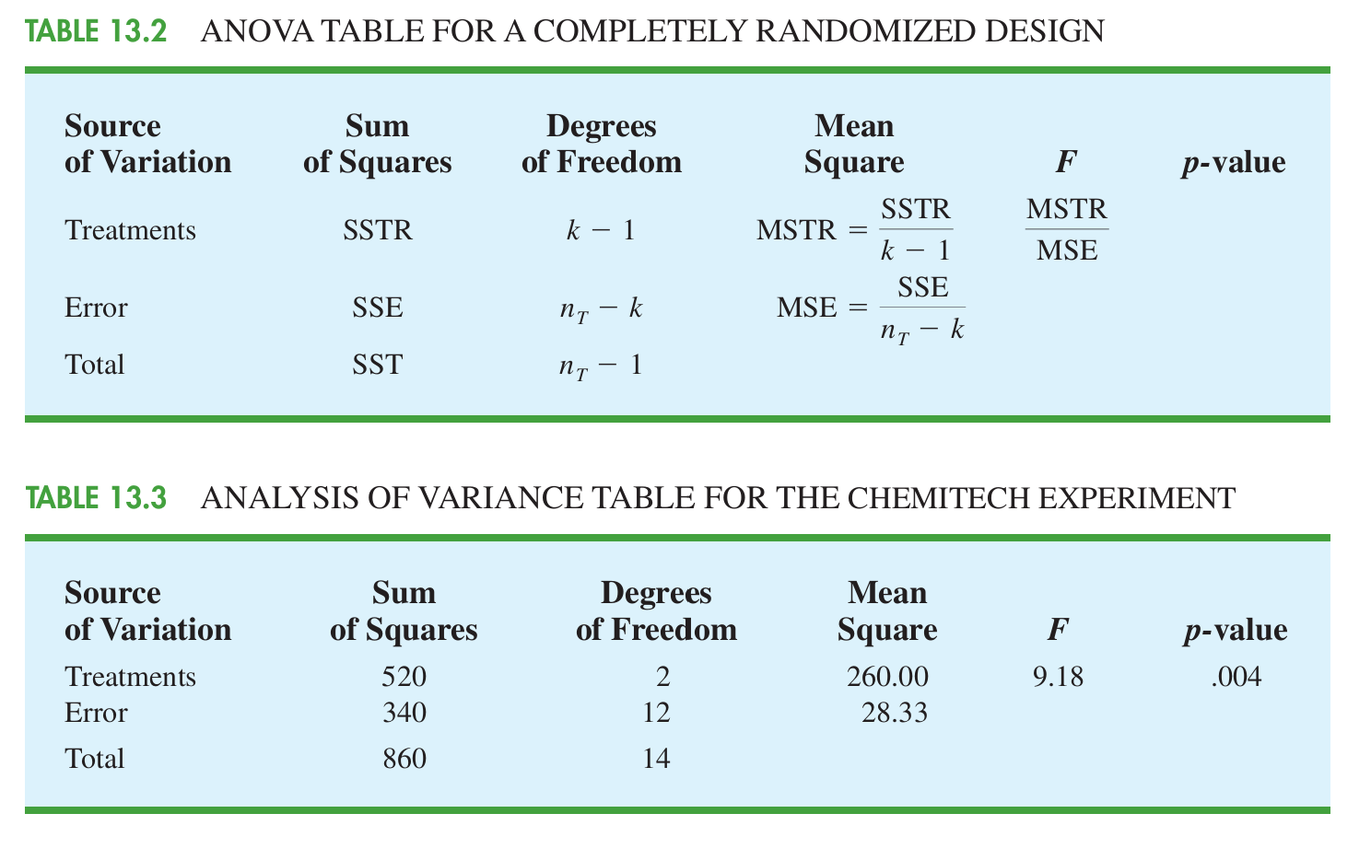

**Entry :**

data1 = read.csv("D:\\Krutarth\\Krutarth - BS\\que-57.csv", header = TRUE)

data1

levels(data1$operator)

y=ordered(data1$operator,levels=c("A","B","C"))

y

ad=aov(x~operator, data=data1)

summary(ad)

**Answer :**

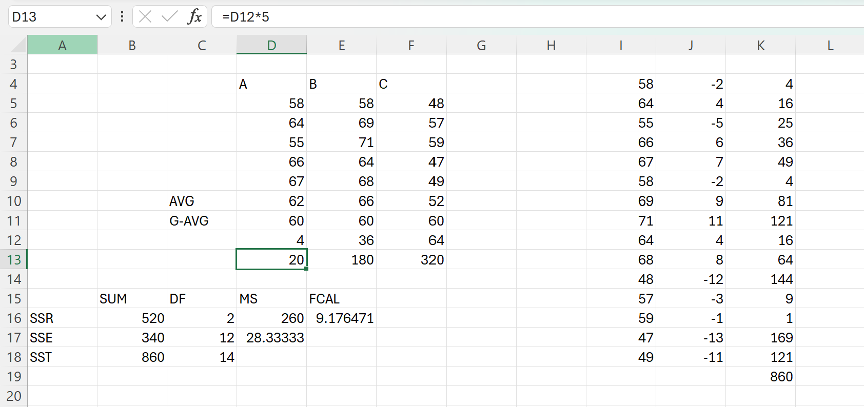

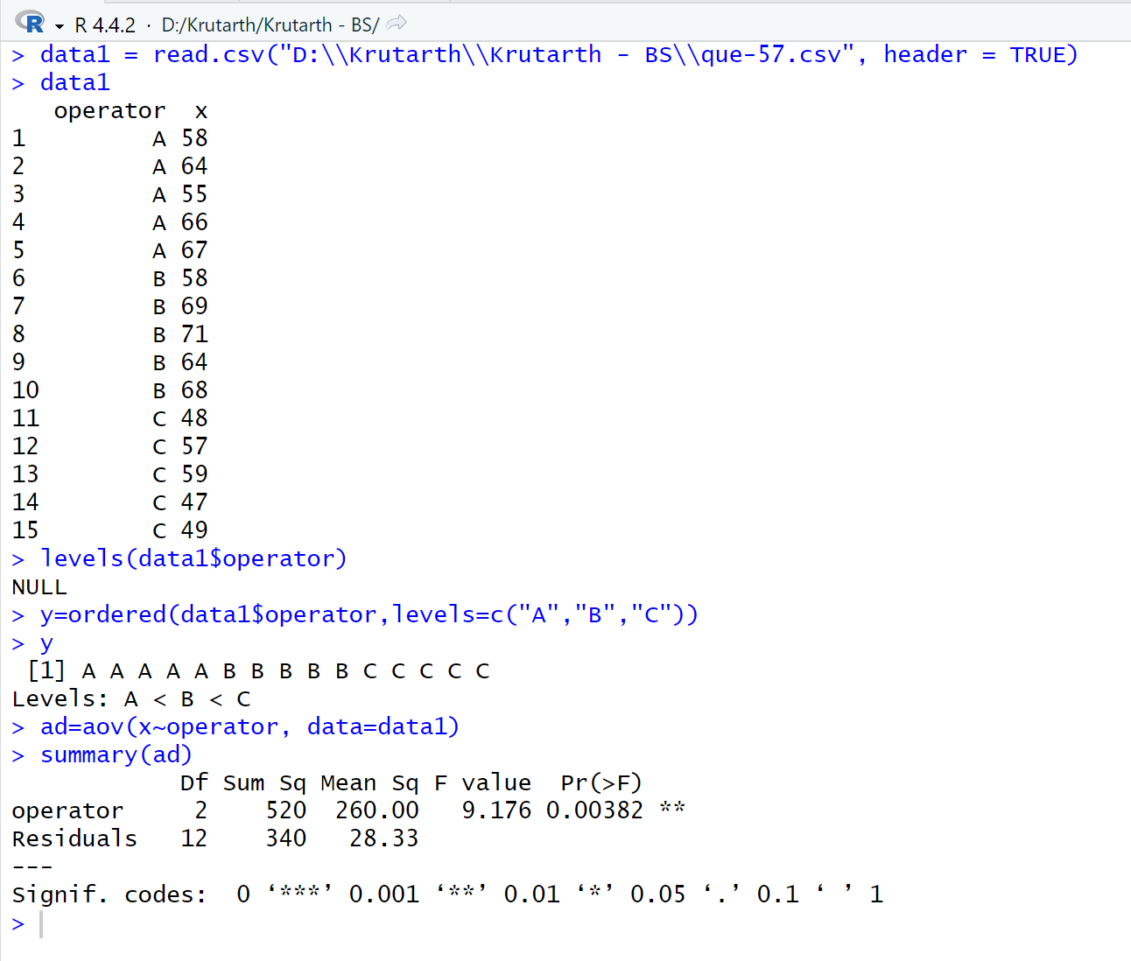

**Que-66 :**

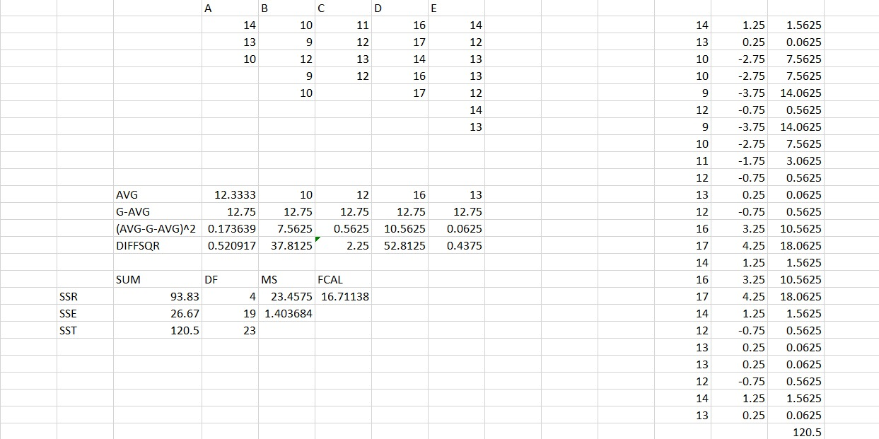

**Entry :**

data1 = read.csv("D:\\Krutarth\\Krutarth - BS\\que-58.csv", header = TRUE)

data1

levels(data1$operator)

y=ordered(data1$operator,levels=c("A","B","C","D","E"))

y

ad=aov(x~operator, data=data1)

summary(ad)

**Answer :**

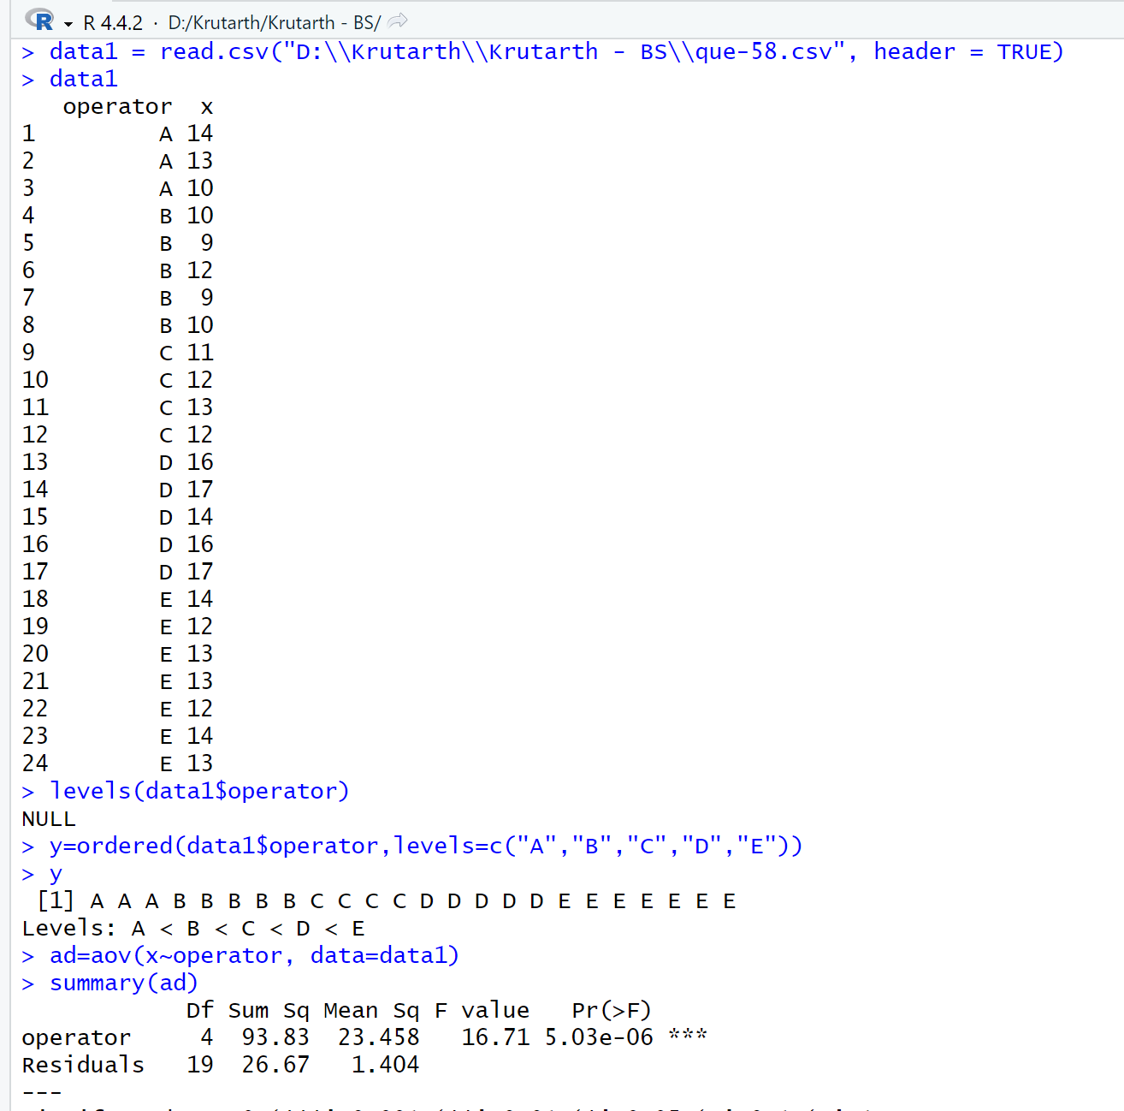

**===========THE END=========**

**KRUTARTH’S BS FOLDER :**

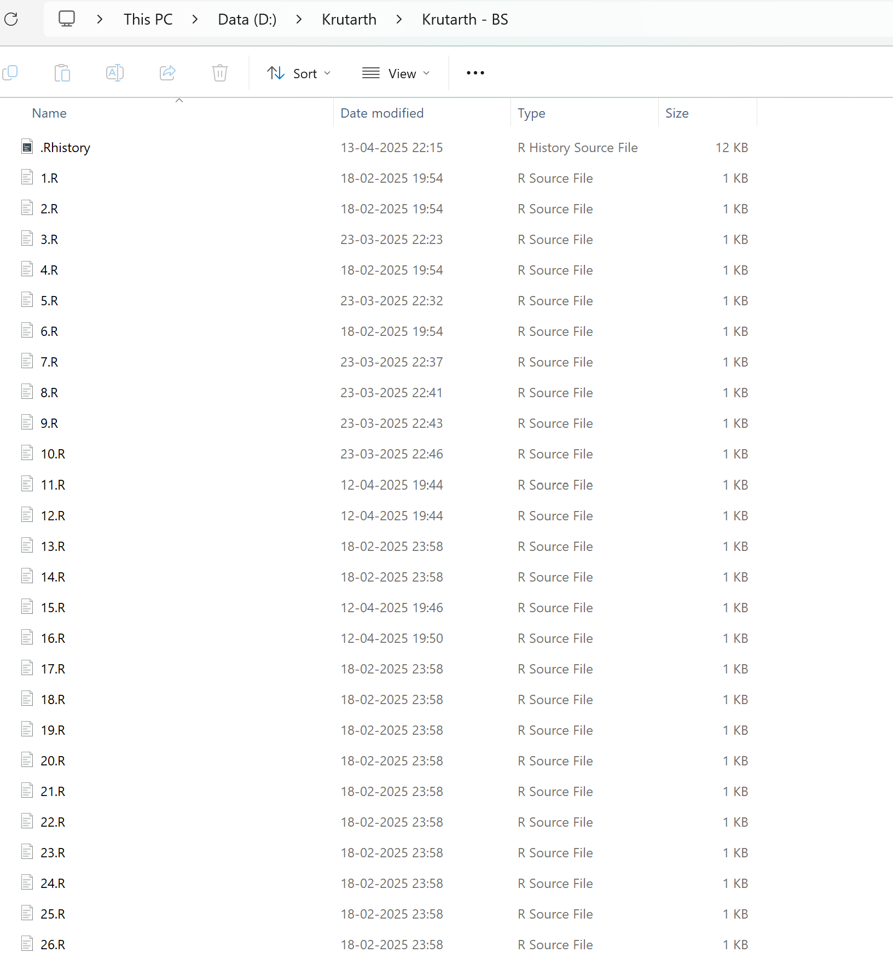

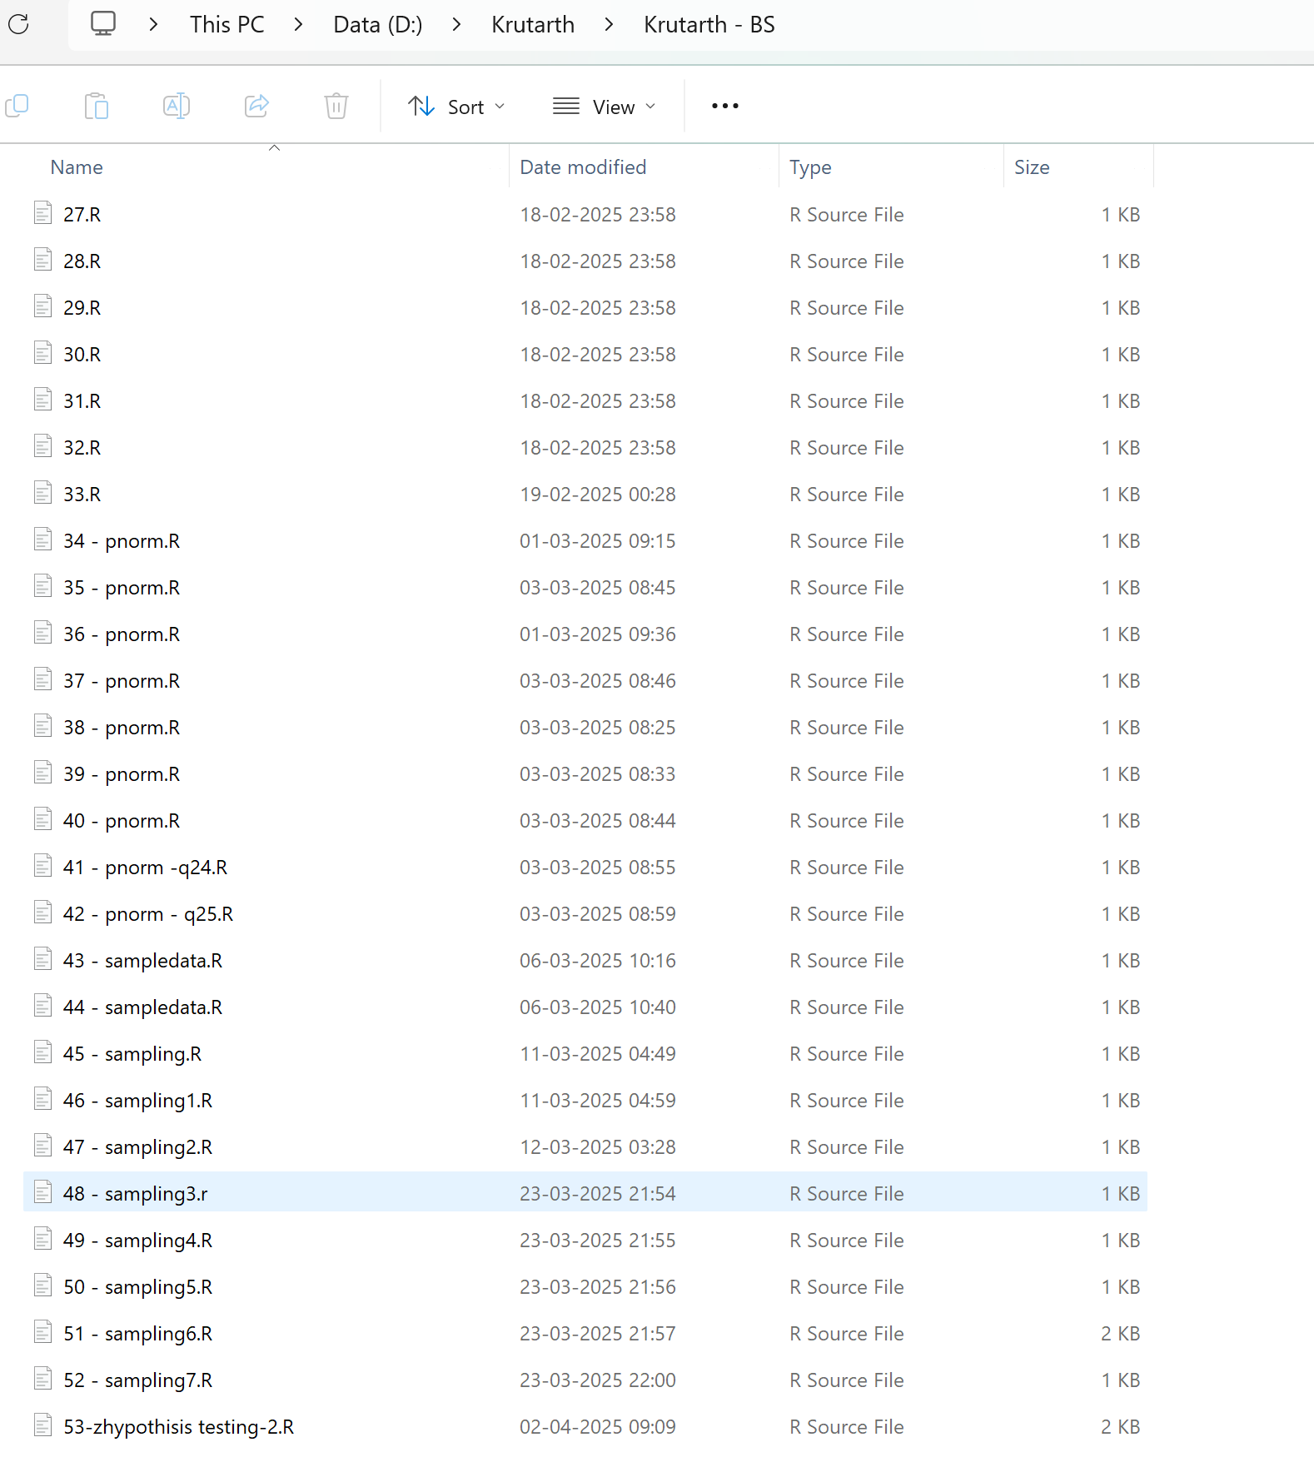

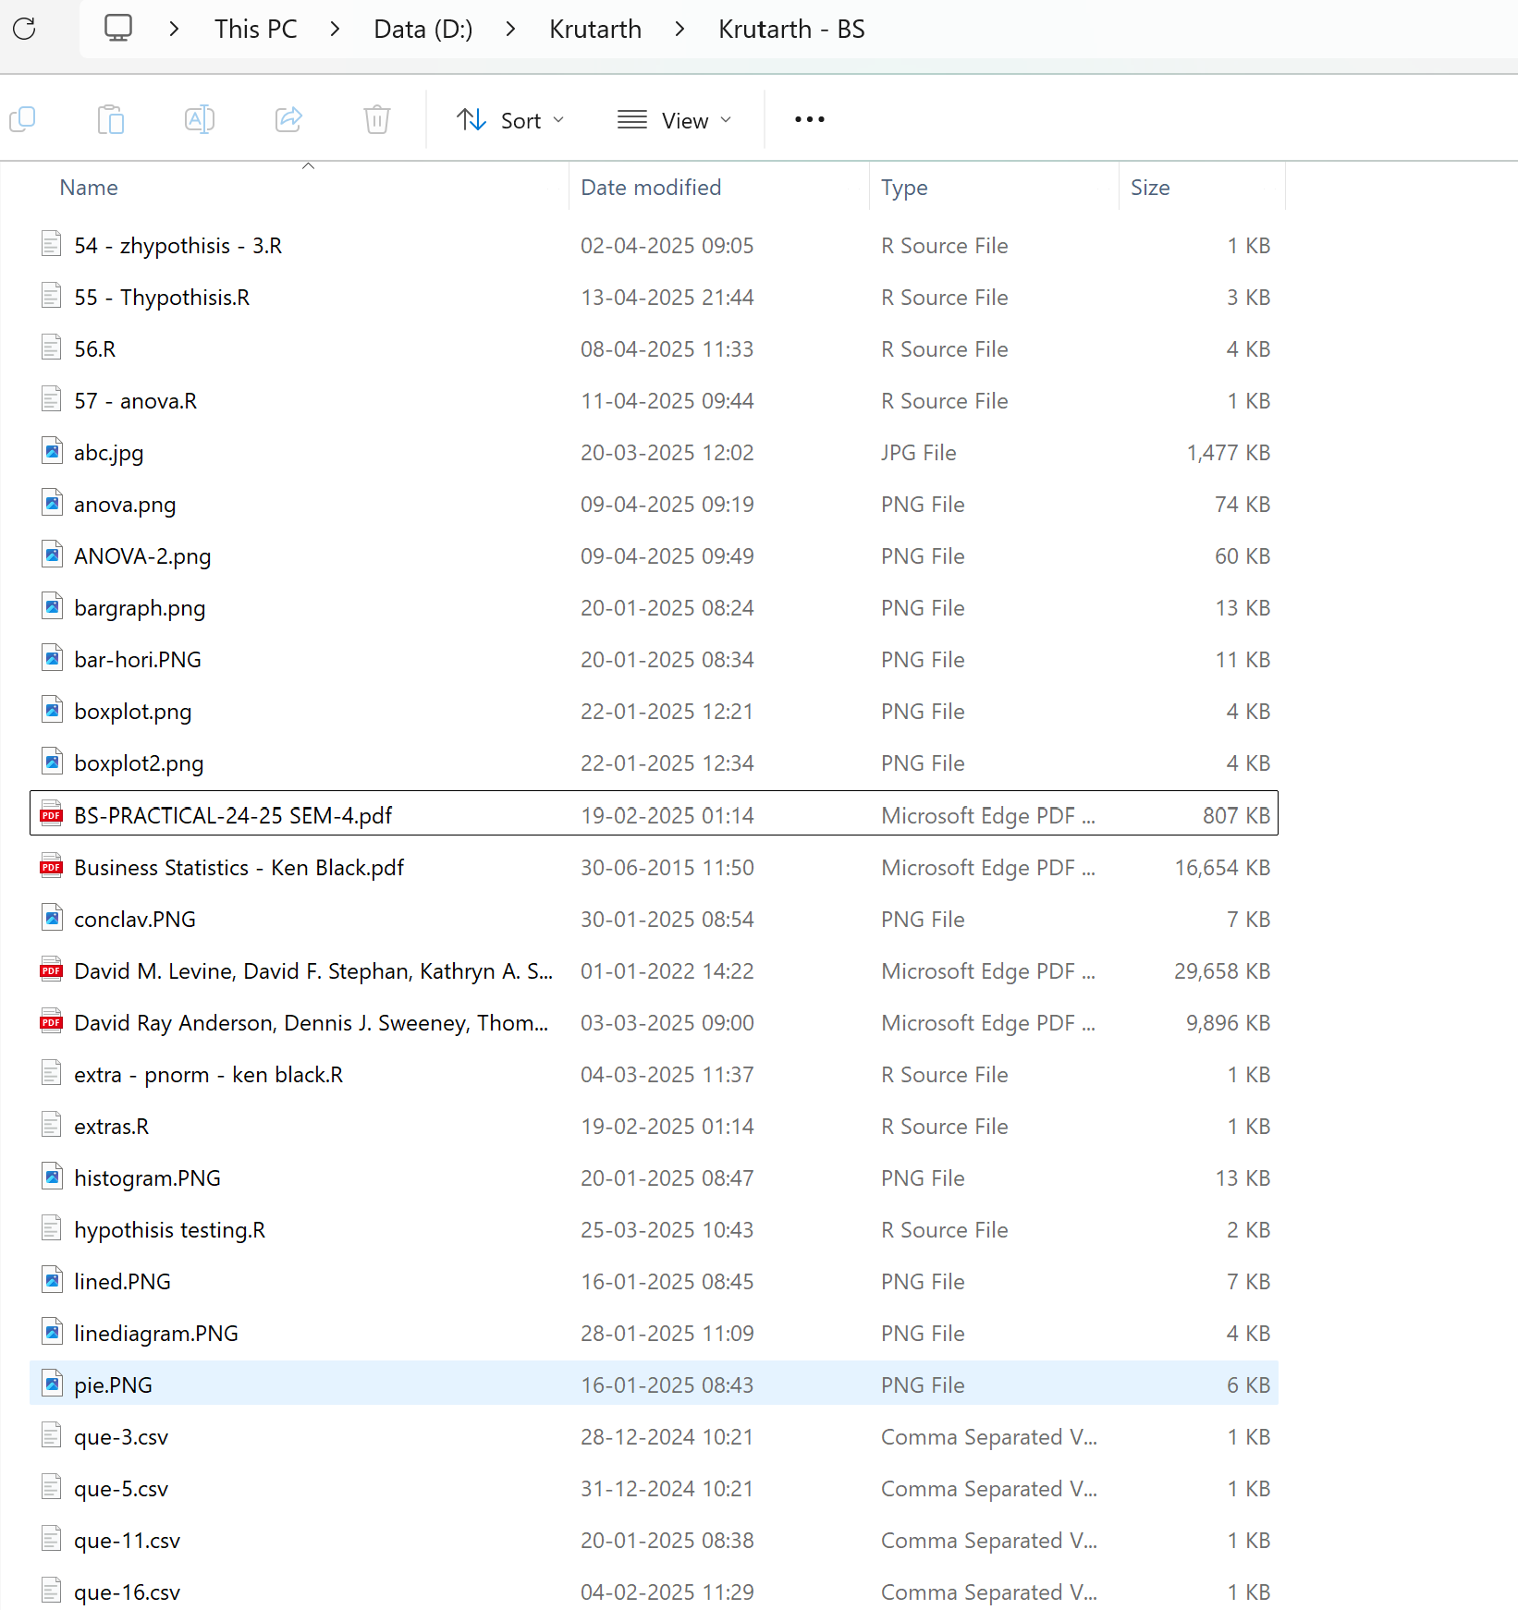

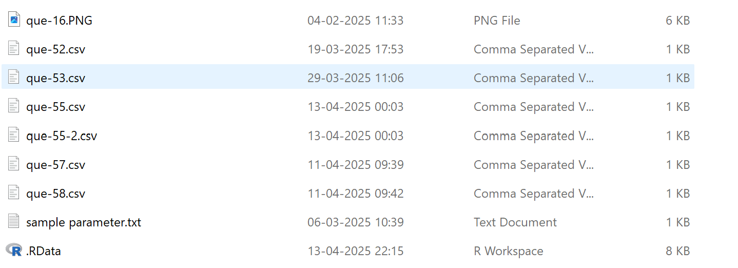

**======== TOTAL : 66 ==========**